**VISVESVARAYA TECHNOLOGICAL UNIVERSITY**

**“JnanaSangama”, Belgaum -590014, Karnataka.**



**LAB REPORT**

**on**

Object Oriented Java Programming (23CS3PCOOJ)

***Submitted by***

**Anmol Bhattarai (1BM23CS039)**

***in partial fulfillment for the award of the degree of***

**BACHELOR OF ENGINEERING**

***in***

**COMPUTER SCIENCE AND ENGINEERING**



**B.M.S. COLLEGE OF ENGINEERING**

**(Autonomous Institution under VTU)**

**BENGALURU-560019**

**Sep-2024 to Jan-2025**

**B.M.S. College of Engineering,**

**Bull Temple Road, Bangalore 560019**

(Affiliated To Visvesvaraya Technological University, Belgaum)

**Department of Computer Science and Engineering**



**CERTIFICATE**

This is to certify that the Lab work entitled “Object Oriented Java Programming (23CS3PCOOJ)” carried out by **Anmol Bhattarai (1BM23CS039),** who is a bonafide student of **B.M.S. College of Engineering.** It is in partial fulfillment for the award of **Bachelor of Engineering in Computer Science and Engineering** of the Visvesvaraya Technological University, Belgaum. The Lab report has been approved as it satisfies the academic requirements in respect of an Object Oriented Java Programming (23CS3PCOOJ) work prescribed for the said degree.

Dr. Jyothi S Nayak Professor & HOD

Department of CSE, BMSCE

Dr. Prasad Gr Assistant Professor

Department of CSE, BMSCE

**Index**

|  |  |  |  |
| --- | --- | --- | --- |
| **Sl.**  **No.** | **Date** | **Experiment Title** | **Page No.** |
| 1 | 9/10/24 | Implement Quadratic Equation | 4 |
| 2 | 16/10/24 | Implement SGPA Calculator | 9 |
| 3 | 23/10/24 | Create Objects for Books | 16 |
| 4 | 30/10/24 | Implement Abstract Class | 23 |
| 5 | 6/11/24 | Bank Account Management | 28 |
| 6 | 13/11/24 | Implement Packages | 40 |
| 7 | 20/11/24 | Implement Exception Handling | 51 |
| 8 | 27/11/24 | Multithreading, Creating Threads in Java | 57 |
| 9 | 27/11/24 | Interface to Perform Integer Division | 60 |
| 10 | 27/11/24 | Implement Deadlock  Implement Inter-process Communication | 65 |

Github Link: https://github.com/Anmolbhattara/JAVA

**Program 1**

Implement Quadratic Equation

**Algorithm:**

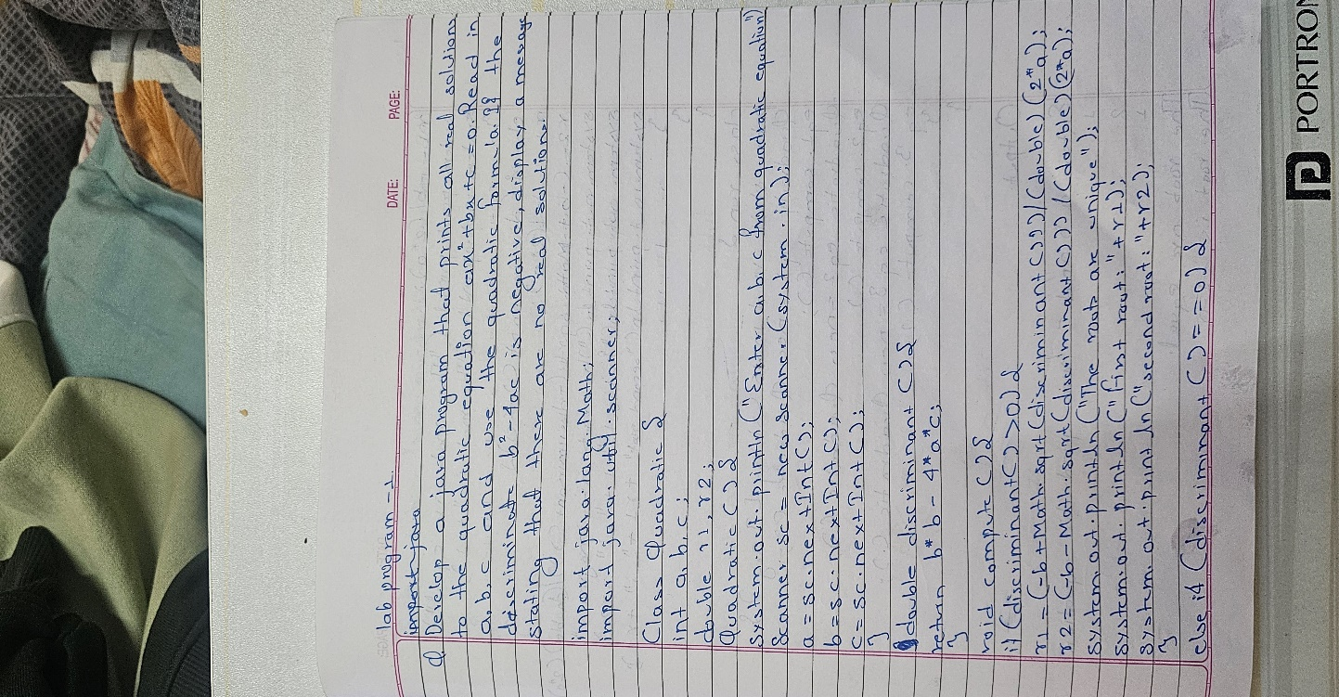

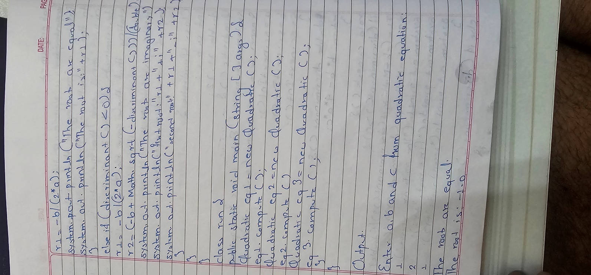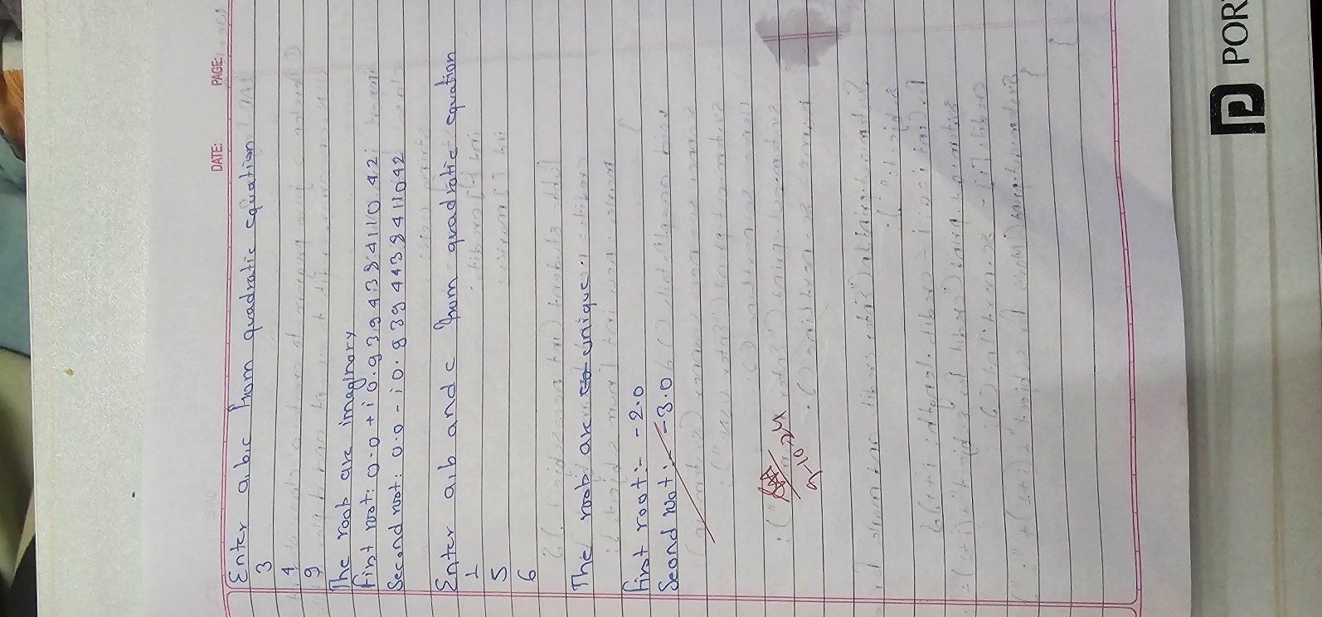

**Code:**

import java.util.Scanner;

public class Main {

public static void main(String[] args) { Scanner scanner = new Scanner(System.in);

System.out.print("Enter coefficient a: "); double a = scanner.nextDouble();

System.out.print("Enter coefficient b: "); double b = scanner.nextDouble();

System.out.print("Enter coefficient c: "); double c = scanner.nextDouble();

double discriminant = b * b - 4 * a * c; if (discriminant > 0) {

double root1 = (-b + Math.sqrt(discriminant)) / (2 * a);

double root2 = (-b - Math.sqrt(discriminant)) / (2 * a); System.out.println("The roots are real and different:"); System.out.println("Root 1: " + root1); System.out.println("Root 2: " + root2);

} else if (discriminant == 0) { double root = -b / (2 * a);

System.out.println("The roots are real and the same:"); System.out.println("Root: " + root);

} else {

System.out.println("The roots are complex:"); double realPart = -b / (2 * a);

double imaginaryPart = Math.sqrt(-discriminant) / (2 * a); System.out.println("Root 1: " + realPart + " + " + imaginaryPart + "i"); System.out.println("Root 2: " + realPart + " - " + imaginaryPart + "i");

System.out.print(“Ayush Ranjan 1BM23CS058");

}

scanner.close();

}

}

Output :

Enter a, b, c:

1

2

1

Equal roots. r1 = r2 = -1.0

Name: Anmol Bhattarai USN: 1BM23CS039

Enter a, b, c:

1

-7

12

r1 = 6.0 r2 = 2.0

Name: Anmol Bhattarai USN: 1BM23CS039

Enter a, b, c:

1

2

5

Roots are imaginary

Name: Anmol Bhattarai USN: 1BM23CS039

**Program 2 :**

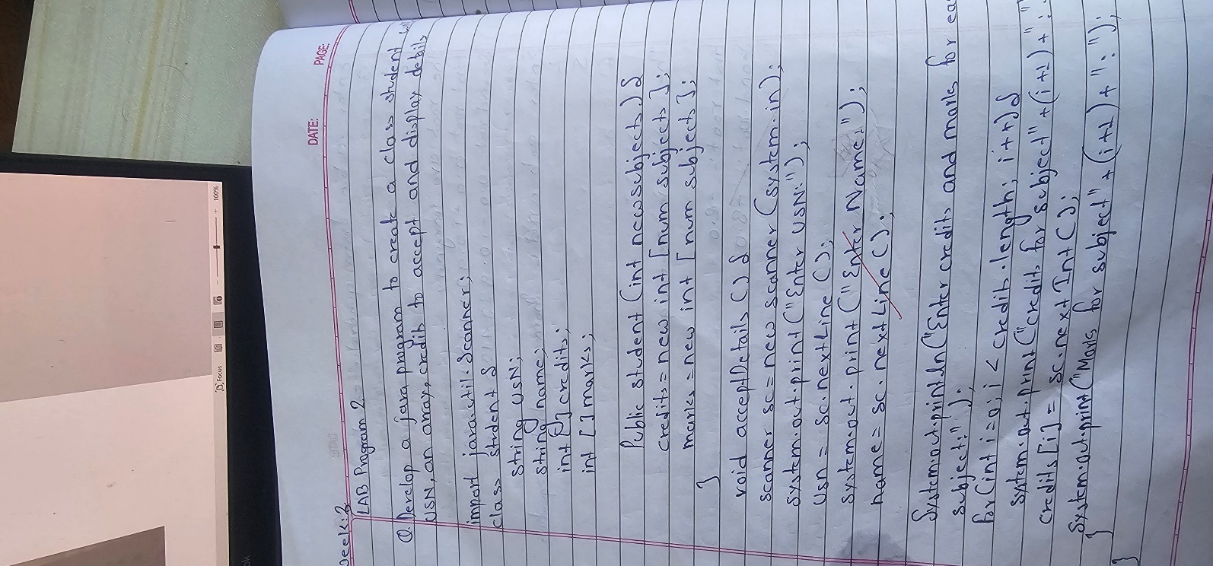**Implement SGPA Calculator Algorithm :**

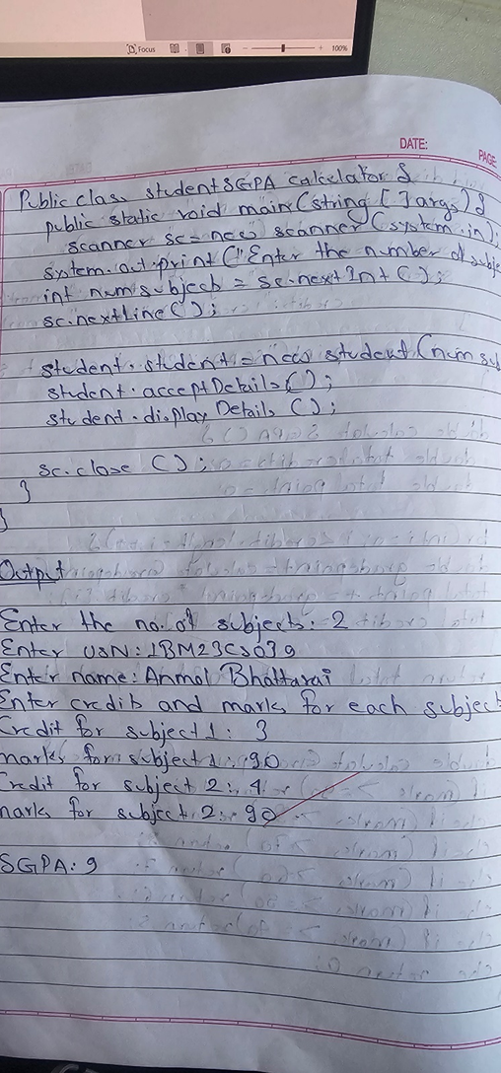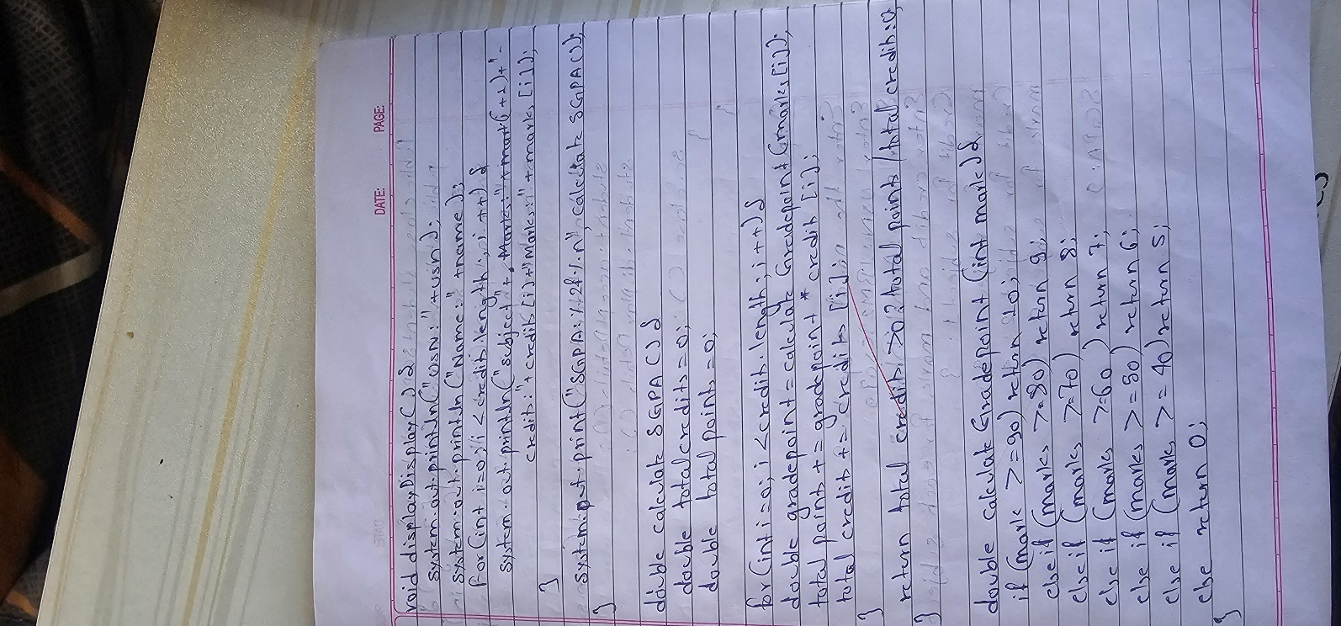

**Code :**

**import java.util.*; class Stud_details {**

**int marks[] = new int[8]; int credit[] = new int[8]; String usn, name;**

**Scanner sc = new Scanner(System.in);**

**void getdetails() {**

**System.out.println("Enter the usn and name:"); usn = sc.next();**

**name = sc.next();**

**System.out.println("Enter the marks for 8 subjects:"); for (int i = 0; i < 8; i++) {**

**marks[i] = sc.nextInt();**

**}**

**System.out.println("Enter the credits for 8 subjects:"); for (int i = 0; i < 8; i++) {**

**credit[i] = sc.nextInt();**

**}**

**}**

**void display() { System.out.println("\nStudent Details:"); System.out.println("USN: " + usn); System.out.println("Name: " + name); for (int i = 0; i < 8; i++) {**

**System.out.println("Marks of Subject " + (i + 1) + ": " + marks[i]);**

**}**

**System.out.println("SGPA: " + calculateSGPA());**

**}**

**double getgradepoint(int mark) { if (mark >= 90) return 10.0; else if (mark >= 80) return 9.0; else if (mark >= 70) return 8.0;**

**else if (mark >= 60) return 7.0; else if (mark >= 50) return 6.0; else if (mark >= 40) return 5.0; else return 0.0;**

**}**

**double calculateSGPA() { int totalcredits = 0; double gradepoint = 0; for (int i = 0; i < 8; i++) {**

**totalcredits += credit[i];**

**}**

**for (int i = 0; i < 8; i++) {**

**gradepoint += getgradepoint(marks[i]) * credit[i];**

**}**

**return (gradepoint / totalcredits);**

**}**

**}**

**public class Student {**

**public static void main(String args[]) { Stud_details s1[] = new Stud_details[3]; for (int j = 0; j < 3; j++) {**

**s1[j] = new Stud_details();**

**}**

**for (int j = 0; j < 3; j++) {**

**System.out.println("\nEnter details of student " + (j + 1)); s1[j].getdetails();**

**}**

**for (int j = 0; j < 3; j++) { s1[j].display();**

**}**

**System.out.println("\nName: Anmol Bhattarai USN: 1BM23CS058");**

**}**

**}**

Output :

Enter details of student 1 Enter the usn and name: 1BM23CS001

John

Enter the marks for 8 subjects: 90

80

70

60

50

40

30

20

Enter the credits for 8 subjects: 4

3

3

3

2

3

2

3

Enter details of student 2 Enter the usn and name: 1BM23CS002

Alice

Enter the marks for 8 subjects: 80

85

75

65

55

45

35

25

Enter the credits for 8 subjects:

4

3

3

3

2

3

2

3

Enter details of student 3 Enter the usn and name: 1BM23CS003

Bob

Enter the marks for 8 subjects: 85

90

95

80

70

60

50

40

Enter the credits for 8 subjects: 4

3

3

3

2

3

2

3

Student Details:

USN: 1BM23CS001

Name: John

Marks of Subject 1: 90

Marks of Subject 2: 80

Marks of Subject 3: 70

Marks of Subject 4: 60

Marks of Subject 5: 50

Marks of Subject 6: 40

Marks of Subject 7: 30

Marks of Subject 8: 20

SGPA: 5.555555555555555

Student Details:

USN: 1BM23CS002

Name: Alice

Marks of Subject 1: 80

Marks of Subject 2: 85

Marks of Subject 3: 75

Marks of Subject 4: 65

Marks of Subject 5: 55

Marks of Subject 6: 45

Marks of Subject 7: 35

Marks of Subject 8: 25

SGPA: 5.5

Student Details:

USN: 1BM23CS003

Name: Bob

Marks of Subject 1: 85

Marks of Subject 2: 90

Marks of Subject 3: 95

Marks of Subject 4: 80

Marks of Subject 5: 70

Marks of Subject 6: 60

Marks of Subject 7: 50

Marks of Subject 8: 40

SGPA: 7.722222222222222

Name: Anmol Bhattarai USN: 1BM23CS039

Program 3 :

Create Objects for Books Algorithm:

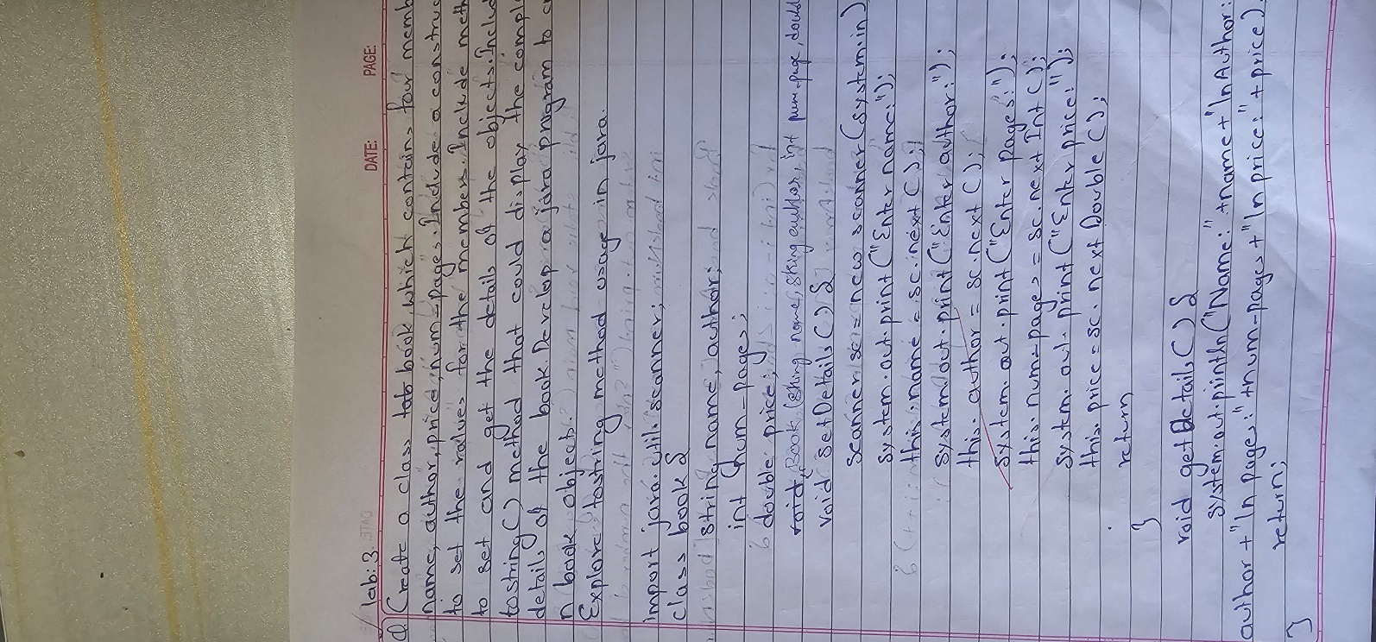

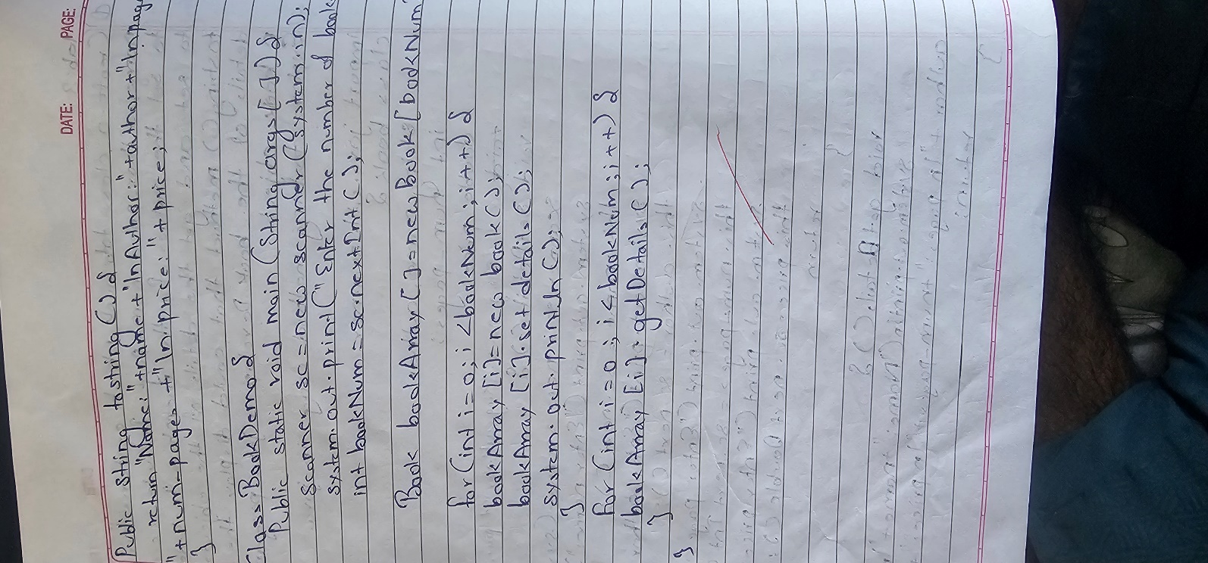

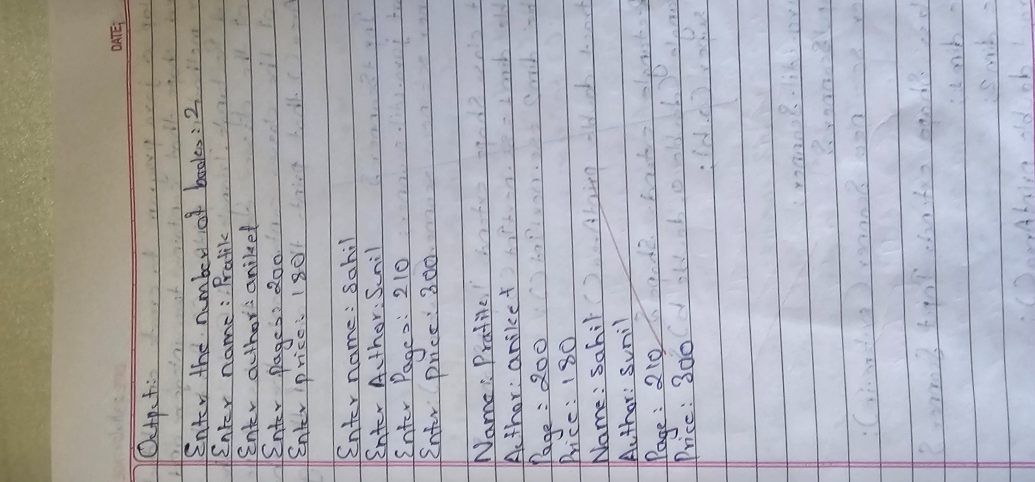

Code :

import java.util.*; class Book {

String name; String author; int price;

int num_pages;

Book(String name, String author, int price, int num_pages) { this.name = name;

this.author = author; this.price = price;

this.num_pages = num_pages;

}

public String toString() {

return "Name: " + name + ", Author: " + author + ", Price: " + price + ", No of Pages: " + num_pages;

}

}

class BookDetails {

public static void main(String[] args) { Scanner sc = new Scanner(System.in);

System.out.println("Enter number of books:"); int n = sc.nextInt();

sc.nextLine();

Book[] book = new Book[n];

System.out.println("Enter name, author, price and number of pages for each book respectively:");

for (int i = 0; i < n; i++) {

System.out.println("Enter details of book " + (i + 1) + ":");

System.out.print("Name: "); String name = sc.nextLine();

System.out.print("Author: "); String author = sc.nextLine();

System.out.print("Price: "); int price = sc.nextInt();

System.out.print("Number of Pages: "); int num_pages = sc.nextInt(); sc.nextLine();

book[i] = new Book(name, author, price, num_pages);

}

for (int i = 0; i < n; i++) { System.out.println("\nBook " + (i + 1) + ":"); System.out.println(book[i].toString());

}

sc.close();

}

}

o/p

Enter number of books:

2

Enter name, author, price and number of pages for each book respectively: Enter details of book 1:

Name: Java Programming Author: James Gosling Price: 500

Number of Pages: 300 Enter details of book 2:

Name: Data Structures Author: Robert Lafore Price: 400

Number of Pages: 450 Book 1:

Name: Java Programming, Author: James Gosling, Price: 500, No of Pages: 300

Book 2:

Name: Data Structures, Author: Robert Lafore, Price: 400, No of Pages: 450

Program 4 : Implement Abstract Class Algorithm:

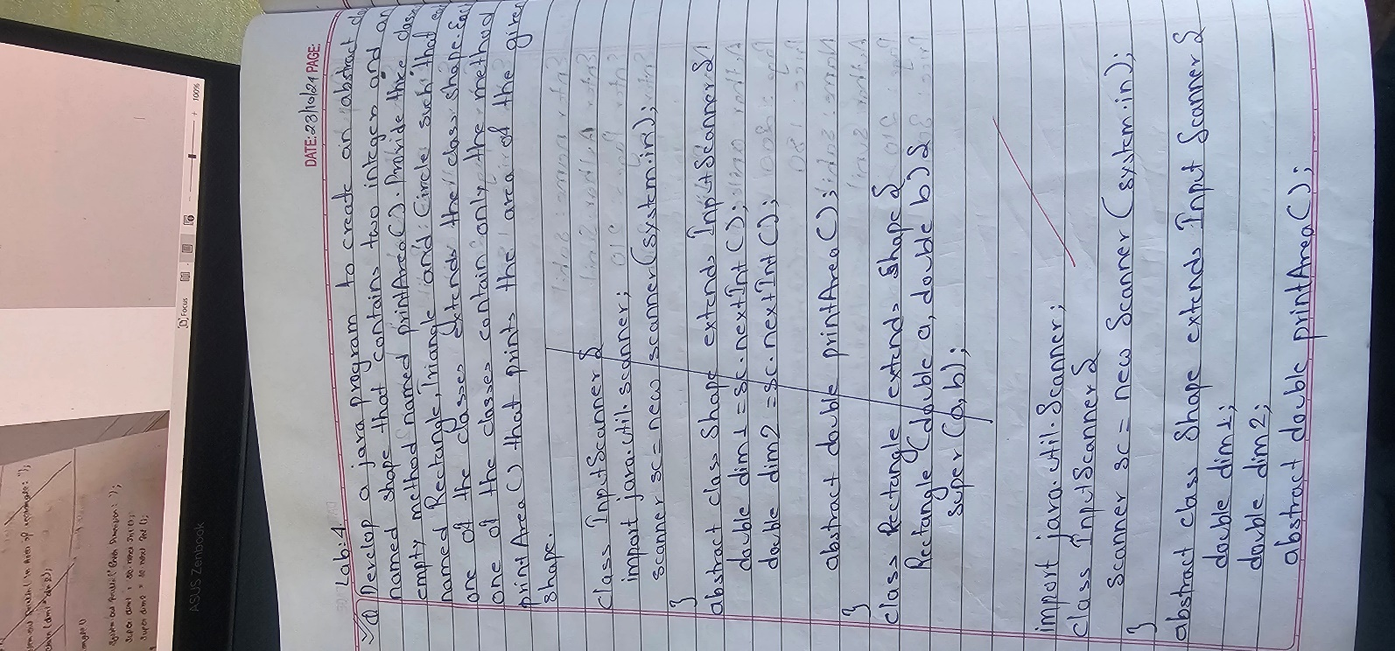

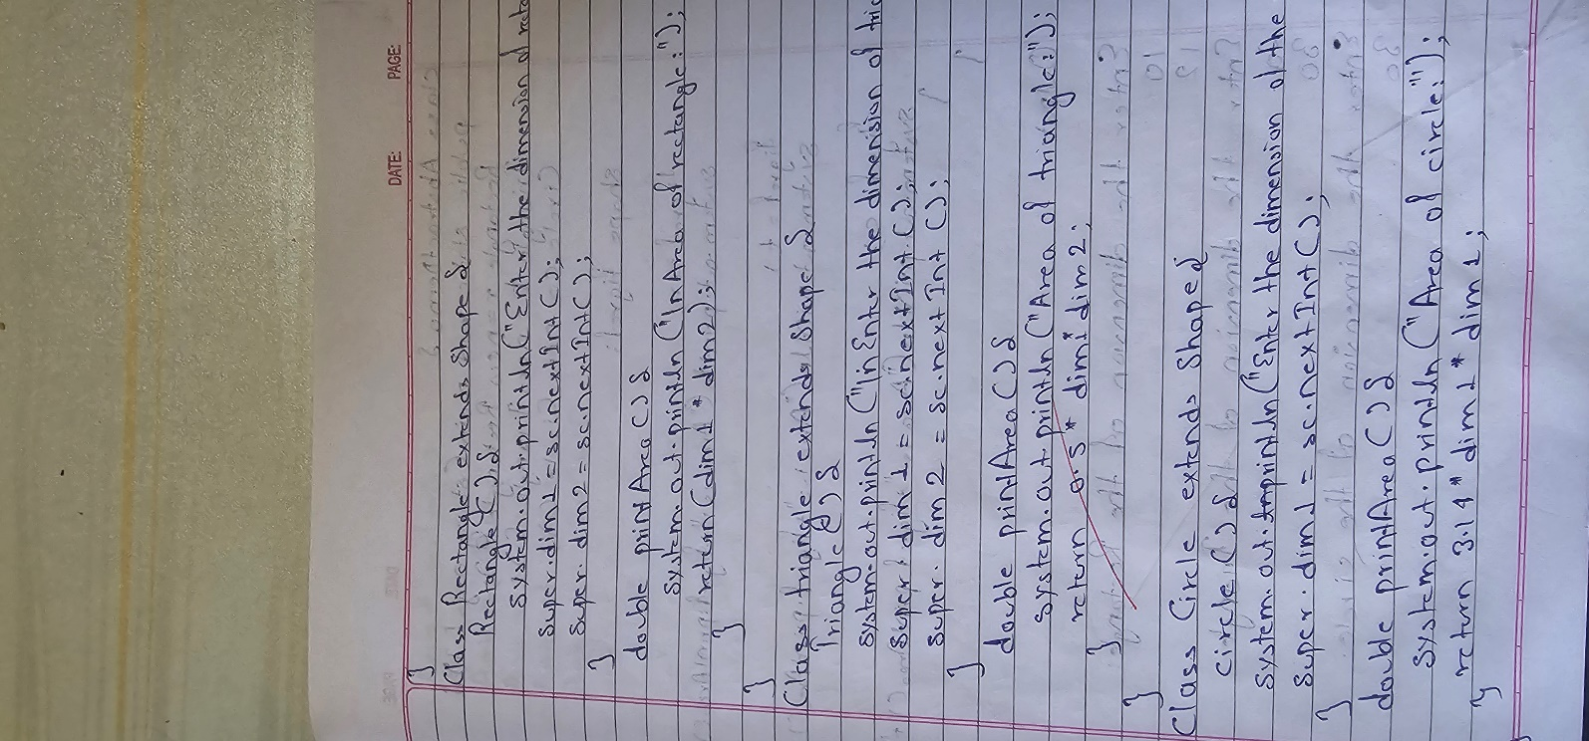

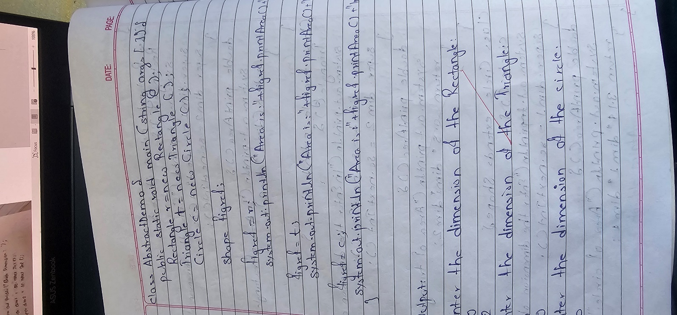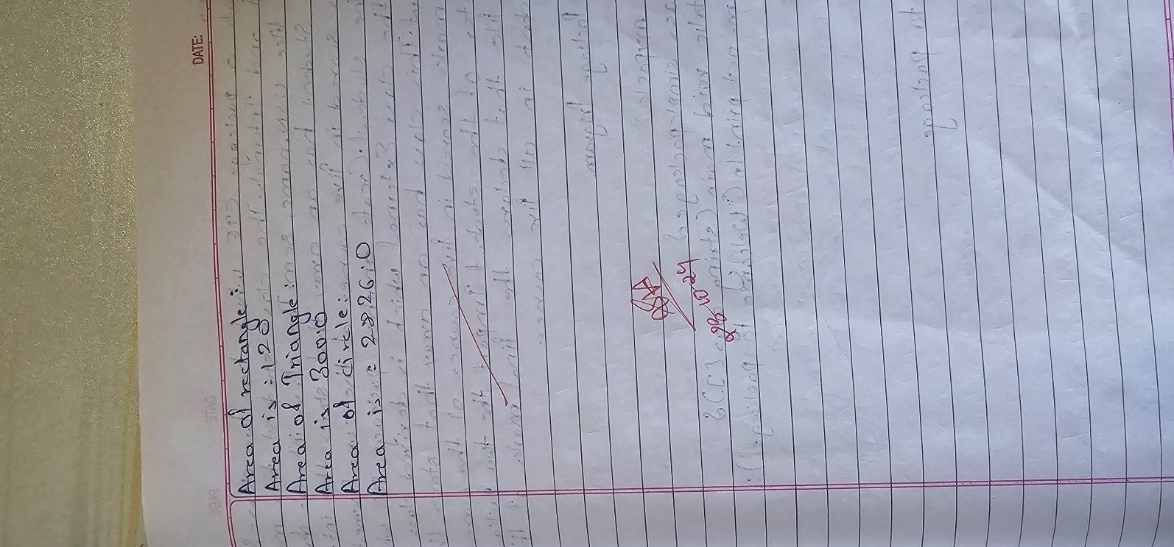

Code :

import java.util.*; abstract class Shape {

int dim1, dim2;

Shape(int a, int b) { dim1 = a;

dim2 = b;

}

abstract void printArea();

}

class Rectangle extends Shape { Rectangle(int l, int b) {

super(l, b);

}

void printArea() {

System.out.println("Area of Rectangle: " + (double)(dim1 * dim2));

}

}

class Triangle extends Shape { Triangle(int b, int h) {

super(b, h);

}

void printArea() {

System.out.println("Area of Triangle: " + (double)(dim1 * dim2 / 2));

}

}

class Circle extends Shape { Circle(int r) {

super(r, 0);

}

void printArea() {

System.out.println("Area of Circle: " + (Math.PI * dim1 * dim1));

}

}

class ShapeArea {

public static void main(String[] args) { Scanner sc = new Scanner(System.in);

System.out.println("Enter length and width of rectangle:"); int length = sc.nextInt();

int breadth = sc.nextInt();

System.out.println("Enter base and height of triangle:"); int base = sc.nextInt();

int height = sc.nextInt();

System.out.println("Enter radius of circle:"); int radius = sc.nextInt();

Rectangle r = new Rectangle(length, breadth); Triangle t = new Triangle(base, height); Circle c = new Circle(radius);

r.printArea(); t.printArea(); c.printArea():

sc.close();

}

}

o/p

Enter length and width of rectangle: 10 5

Enter base and height of triangle: 8 6

Enter radius of circle:

7

Area of Rectangle: 50.0 Area of Triangle: 24.0

Area of Circle: 153.93804002589985

Program 5 : Bank Account Management Algorithm :

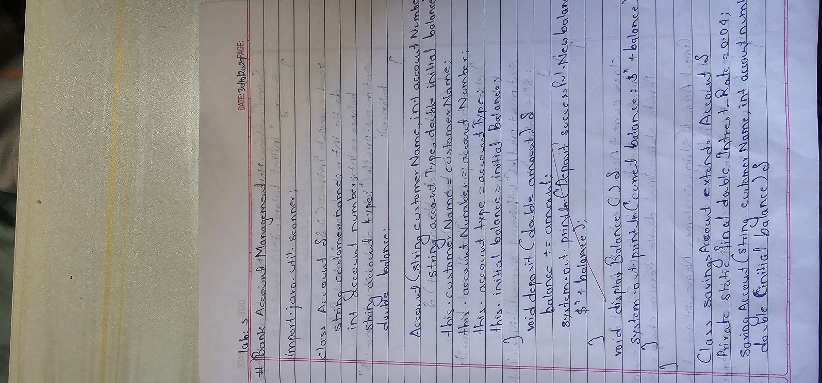

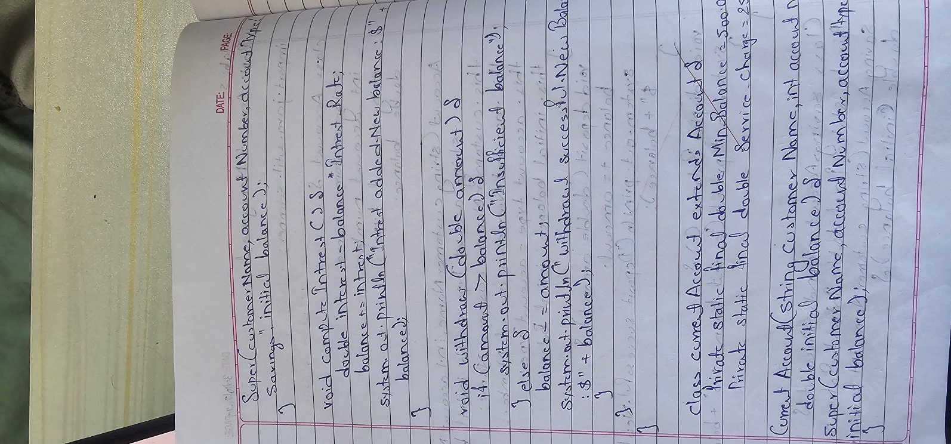

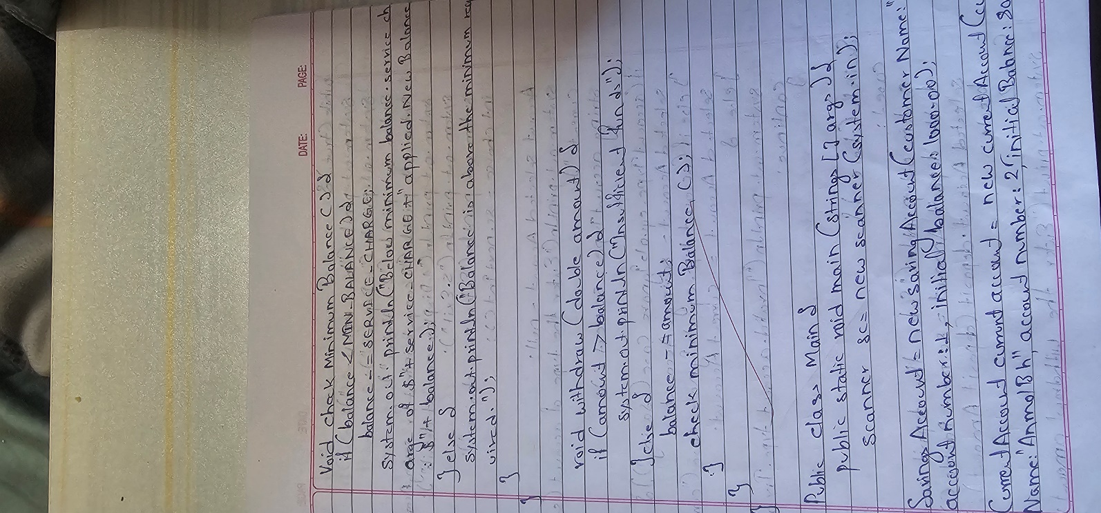

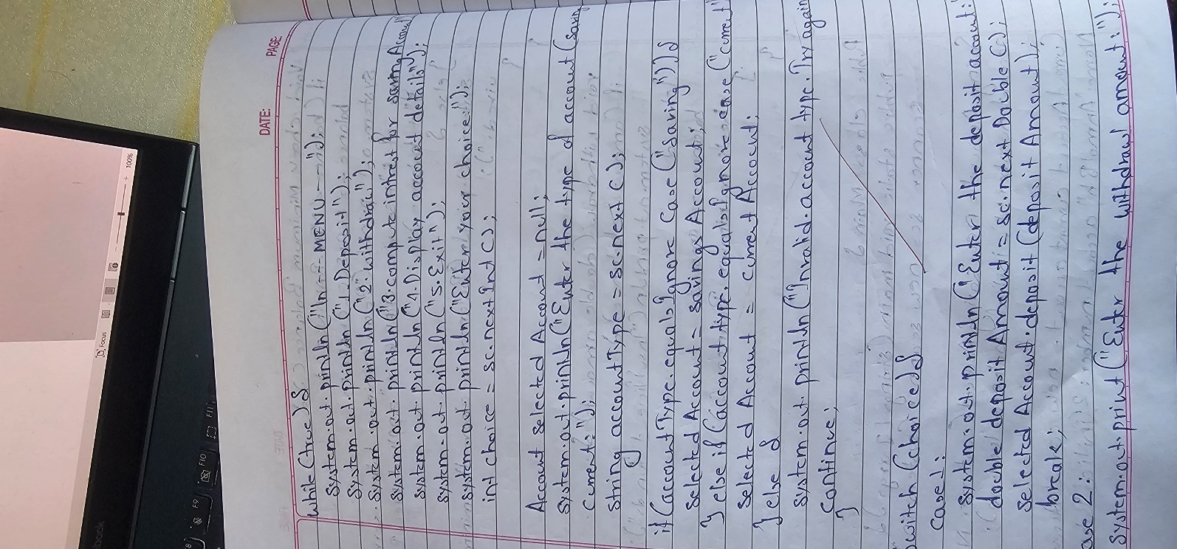

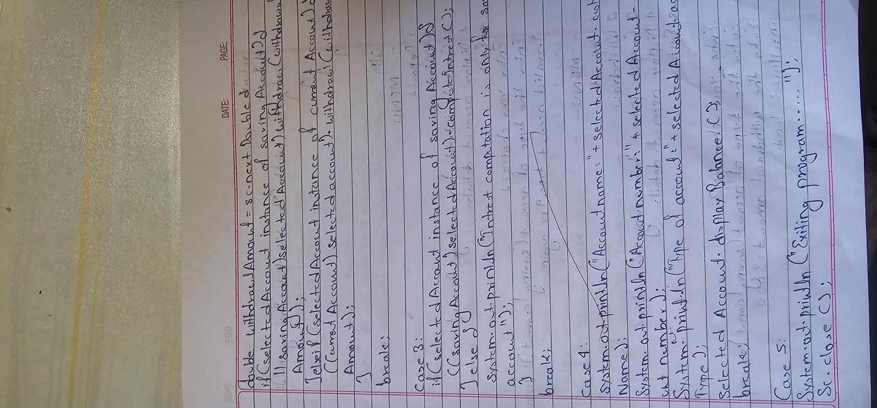

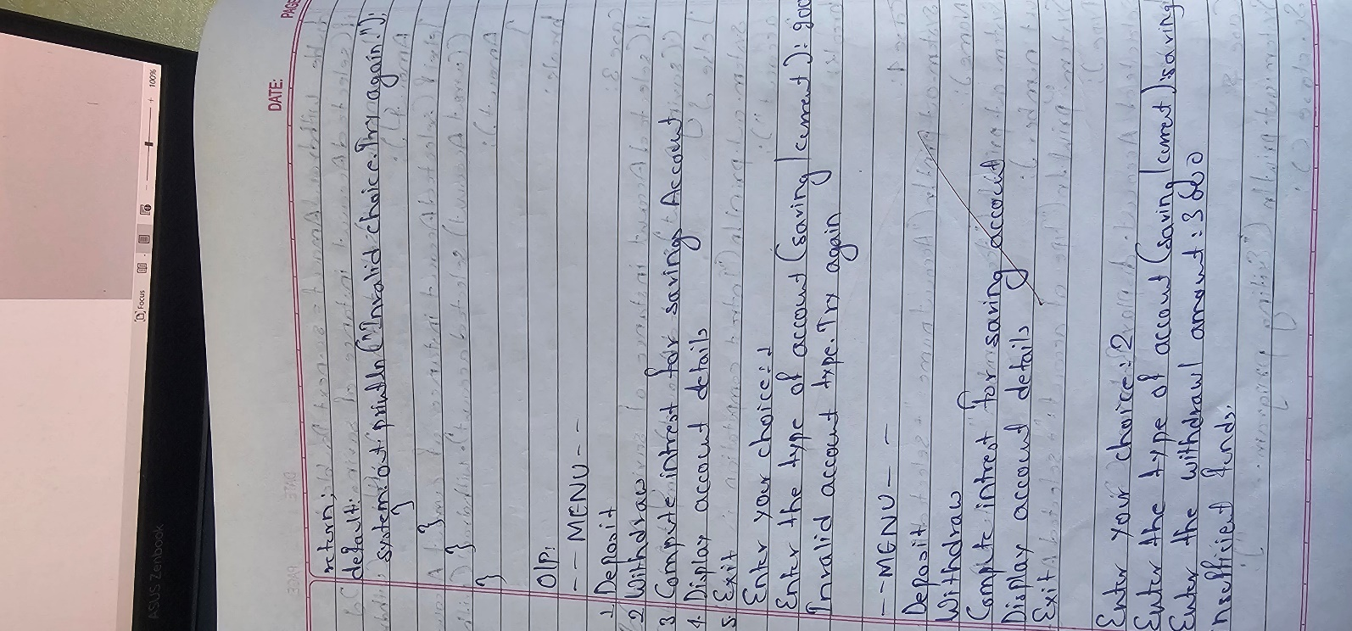

Code :

import java.util.Scanner; class Account {

String customerName; int accountNumber; String accountType; double balance;

Account(String customerName, int accountNumber, String accountType, double initialBalance) {

this.customerName = customerName; this.accountNumber = accountNumber; this.accountType = accountType; this.balance = initialBalance;

}

void deposit(double amount) { balance += amount;

System.out.println("Deposit successful. New balance: $" + balance);

}

void displayBalance() {

System.out.println("Current balance: $" + balance);

}

}

class SavingsAccount extends Account {

private static final double INTEREST_RATE = 0.04;

SavingsAccount(String customerName, int accountNumber, double initialBalance) {

super(customerName, accountNumber, "Savings", initialBalance);

}

void computeInterest() {

double interest = balance * INTEREST_RATE; balance += interest;

System.out.println("Interest added. New balance: $" + balance);

}

void withdraw(double amount) { if (amount > balance) {

System.out.println("Insufficient funds.");

} else {

balance -= amount;

System.out.println("Withdrawal successful. New balance: $" + balance);

}

}

}

class CurrentAccount extends Account {

private static final double MIN_BALANCE = 500.00; private static final double SERVICE_CHARGE = 25.00;

CurrentAccount(String customerName, int accountNumber, double initialBalance) {

super(customerName, accountNumber, "Current", initialBalance);

}

void checkMinimumBalance() {

if (balance < MIN_BALANCE) { balance -= SERVICE_CHARGE;

System.out.println("Below minimum balance. Service charge of $" + SERVICE_CHARGE + " applied. New balance: $" + balance);

} else {

System.out.println("Balance is above the minimum required.");

}

}

void withdraw(double amount) { if (amount > balance) {

System.out.println("Insufficient funds.");

} else {

balance -= amount; checkMinimumBalance();

}

}

}

public class Main {

public static void main(String[] args) { Scanner sc = new Scanner(System.in);

SavingsAccount savingsAccount = new SavingsAccount("Ar", 1, 1000.00);

CurrentAccount currentAccount = new CurrentAccount("Ayush", 2, 800.00);

while (true) {

System.out.println("\n---MENU---"); System.out.println("1. Deposit"); System.out.println("2. Withdraw");

System.out.println("3. Compute interest for SavingsAccount"); System.out.println("4. Display account details"); System.out.println("5. Exit");

System.out.print("Enter your choice: "); int choice = sc.nextInt();

Account selectedAccount = null;

System.out.print("Enter the type of account (saving/current): "); String accountType = sc.next();

if (accountType.equalsIgnoreCase("saving")) { selectedAccount = savingsAccount;

} else if (accountType.equalsIgnoreCase("current")) { selectedAccount = currentAccount;

} else {

System.out.println("Invalid account type. Try again."); continue;

}

switch (choice) { case 1:

System.out.print("Enter the deposit amount: "); double depositAmount = sc.nextDouble(); selectedAccount.deposit(depositAmount); break;

case 2:

System.out.print("Enter the withdrawal amount: "); double withdrawalAmount = sc.nextDouble();

if (selectedAccount instanceof SavingsAccount) { ((SavingsAccount)

selectedAccount).withdraw(withdrawalAmount);

} else if (selectedAccount instanceof CurrentAccount) { ((CurrentAccount)

selectedAccount).withdraw(withdrawalAmount);

}

break; case 3:

accounts.");

if (selectedAccount instanceof SavingsAccount) { ((SavingsAccount) selectedAccount).computeInterest();

} else {

System.out.println("Interest computation is only for savings

}

break; case 4:

System.out.println("Account name: " + selectedAccount.customerName);

System.out.println("Account number: " + selectedAccount.accountNumber);

System.out.println("Type of account: " + selectedAccount.accountType);

selectedAccount.displayBalance(); break;

case 5:

System.out.println("Exiting program..."); sc.close();

return; default:

System.out.println("Invalid choice. Try again.");

}

}

}

}

Output:

---MENU---

1. Deposit
2. Withdraw
3. Compute interest for SavingsAccount
4. Display account details
5. Exit

Enter your choice: 1

Enter the type of account (saving/current): saving Enter the deposit amount: 500

Deposit successful. New balance: $1500.0

---MENU---

1. Deposit
2. Withdraw
3. Compute interest for SavingsAccount
4. Display account details
5. Exit

Enter your choice: 2

Enter the type of account (saving/current): current Enter the withdrawal amount: 400

Withdrawal successful. New balance: $400.0

Below minimum balance. Service charge of $25.0 applied. New balance:

$375.0

---MENU---

1. Deposit
2. Withdraw
3. Compute interest for SavingsAccount
4. Display account details
5. Exit

Enter your choice: 3

Enter the type of account (saving/current): saving Interest added. New balance: $1560.0

---MENU---

1. Deposit
2. Withdraw
3. Compute interest for SavingsAccount
4. Display account details
5. Exit

Enter your choice: 4

Enter the type of account (saving/current): current Account name: Ayush

Account number: 2

Type of account: Current Current balance: $375.0

---MENU---

1. Deposit
2. Withdraw
3. Compute interest for SavingsAccount
4. Display account details
5. Exit

Enter your choice: 5 Exiting

Program No: 6 Implement Packages

Algorithm :

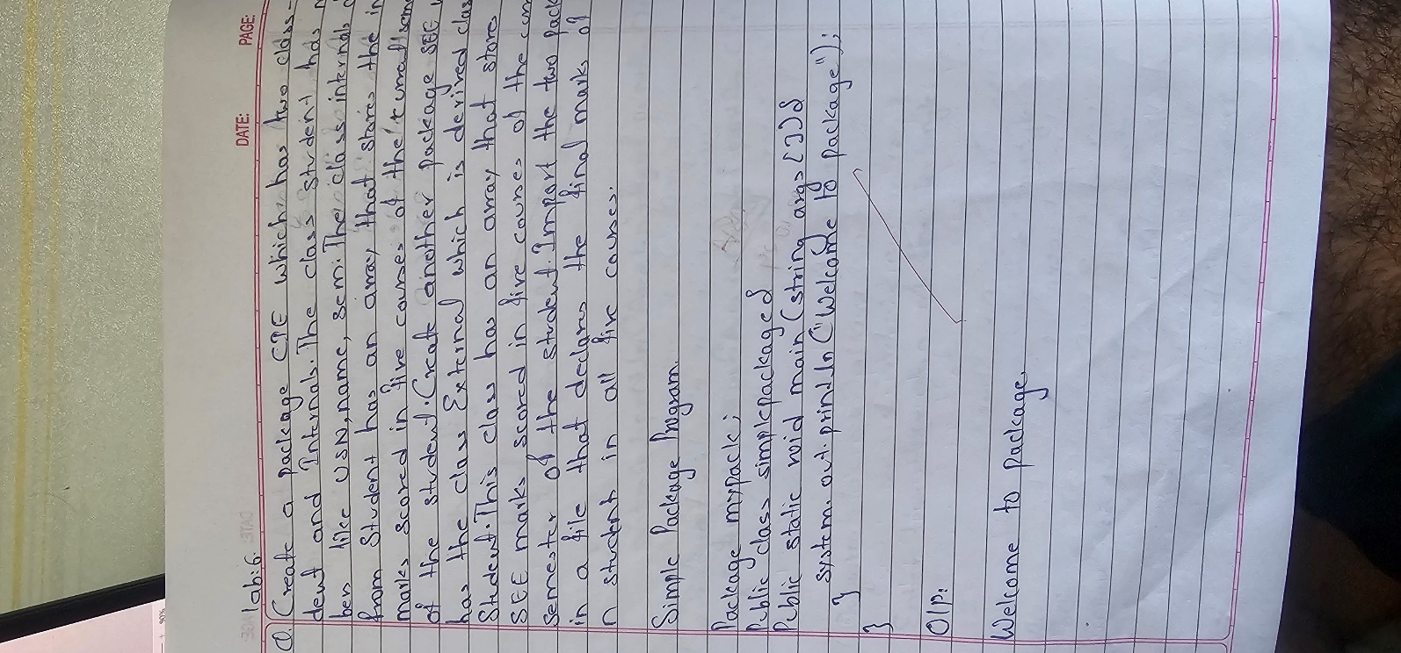

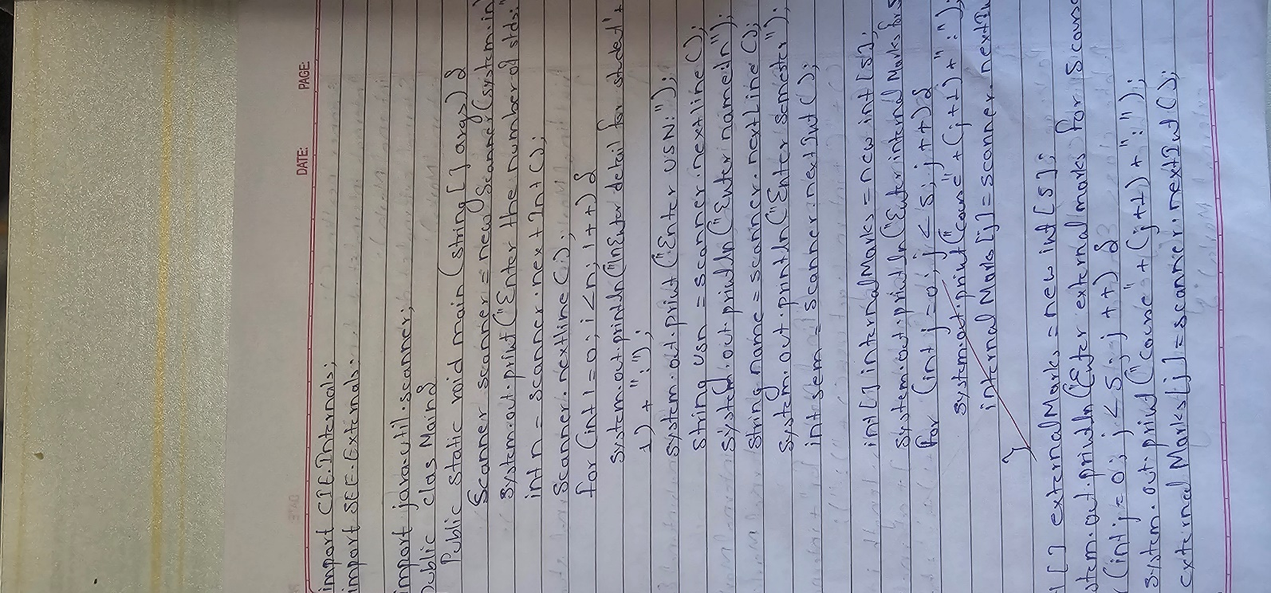

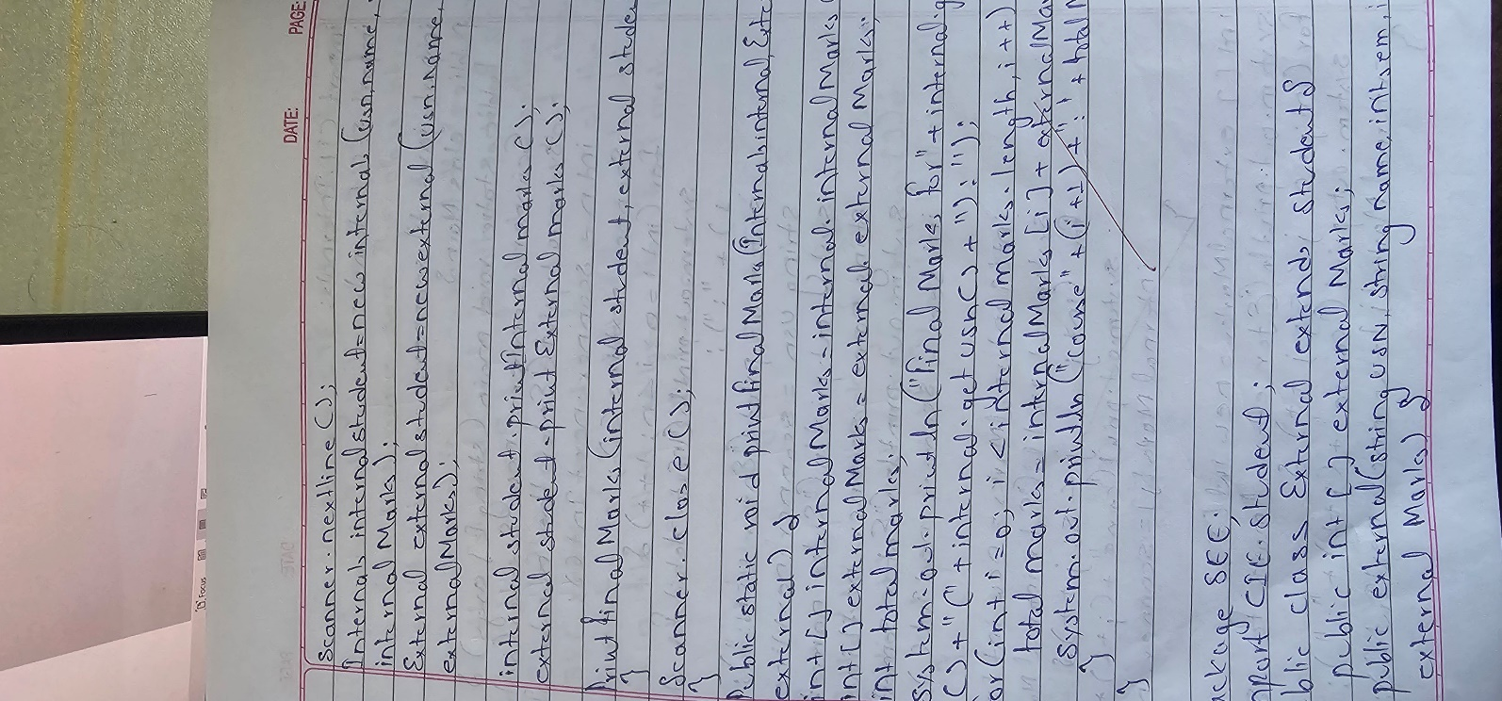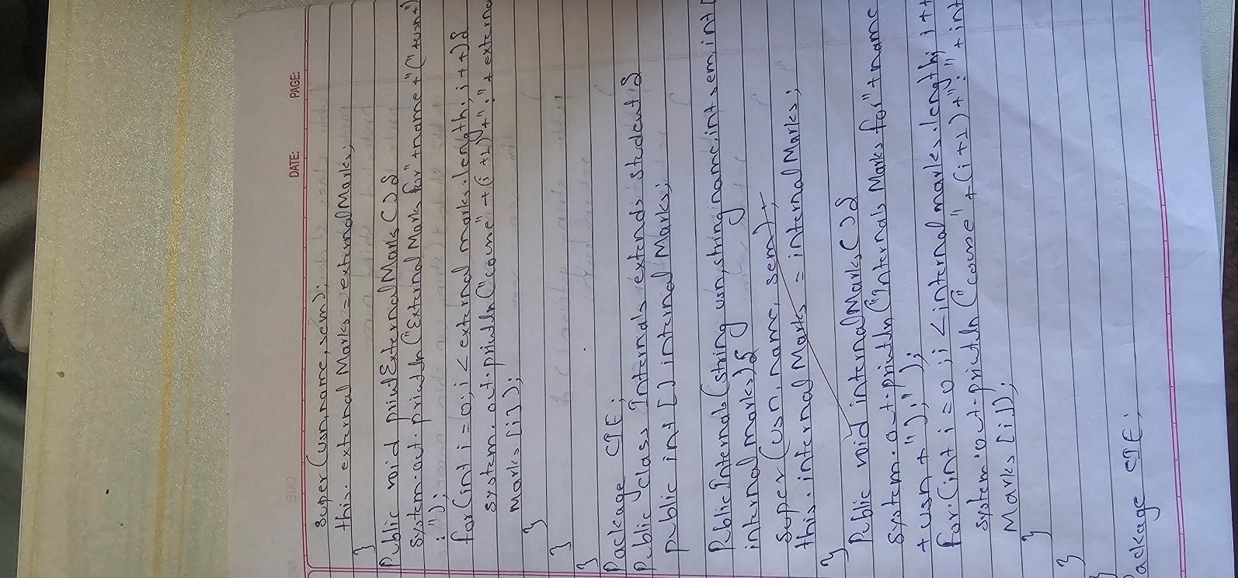

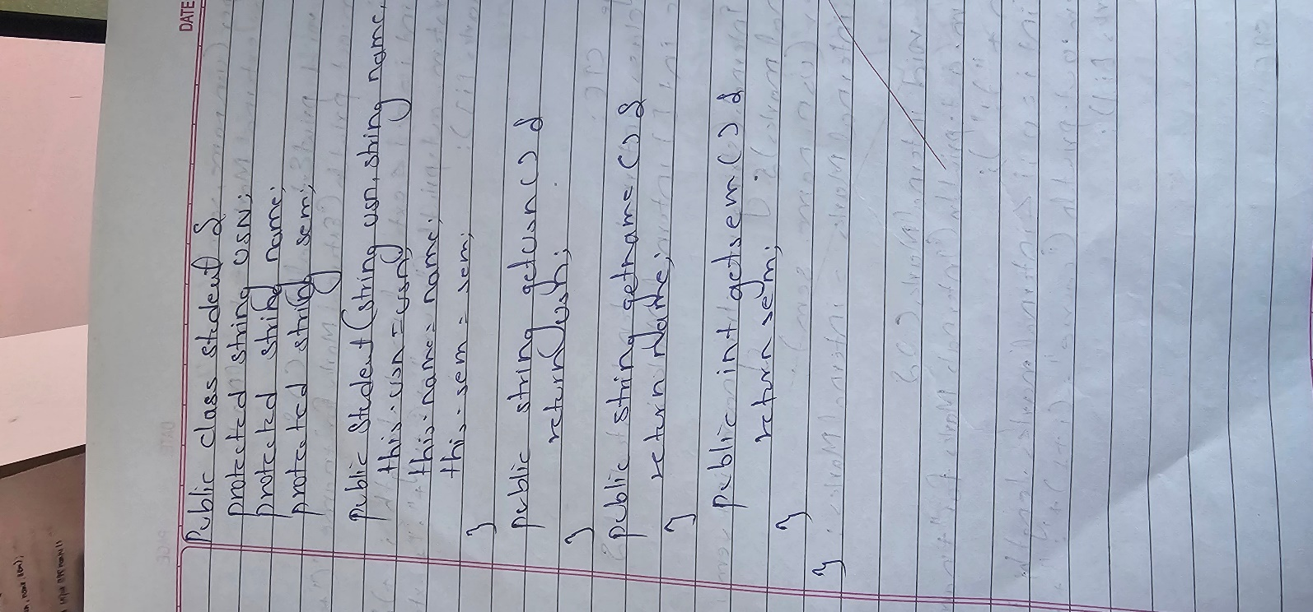

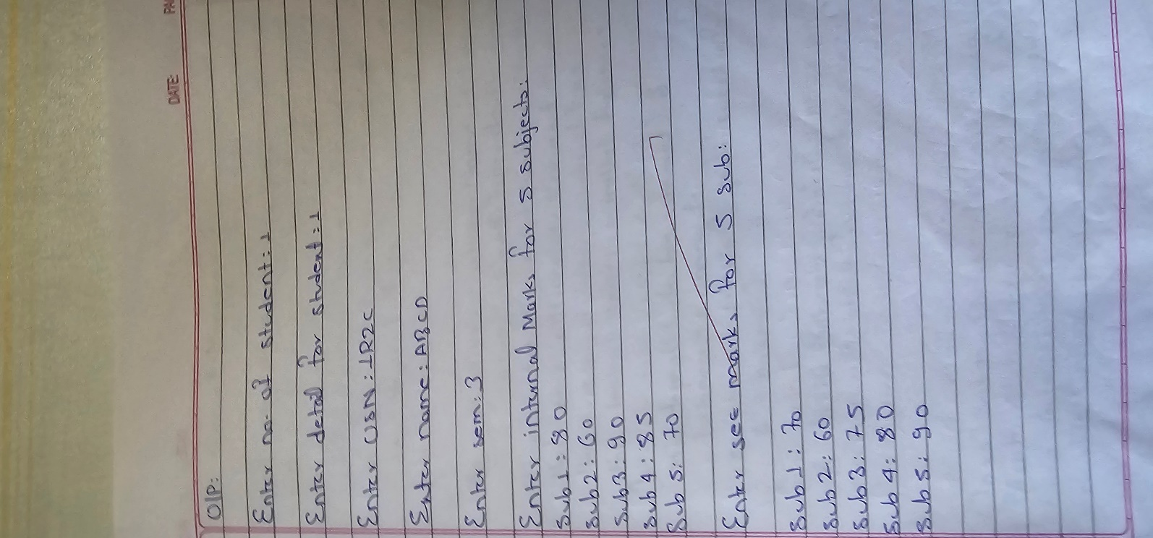

Code:

package SEE; import CIE.Student;

public class External extends Student { public int[] externalMarks;

public External(String usn, String name, int sem, int[] externalMarks) { super(usn, name, sem);

this.externalMarks = externalMarks;

}

public void printExternalMarks() {

System.out.println("External Marks for " + name + " (" + usn + "):"); for (int i = 0; i < externalMarks.length; i++) {

System.out.println("Course " + (i + 1) + ": " + externalMarks[i]);

}

}

}

package CIE;

public class Internals extends Student { public int[] internalMarks;

public Internals(String usn, String name, int sem, int[] internalMarks) { super(usn, name, sem);

this.internalMarks = internalMarks;

}

public void printInternalMarks() {

System.out.println("Internal Marks for " + name + " (" + usn + "):"); for (int i = 0; i < internalMarks.length; i++) {

System.out.println("Course " + (i + 1) + ": " + internalMarks[i]);

}

}

}

import CIE.Internals; import SEE.External;

import java.util.Scanner; public class Main {

public static void main(String[] args) {

Scanner scanner = new Scanner(System.in);

System.out.print("Enter number of students: "); int n = scanner.nextInt();

scanner.nextLine();

for (int i = 0; i < n; i++) {

System.out.println("\nEnter details for Student " + (i + 1) + ":"); System.out.print("Enter USN: ");

String usn = scanner.nextLine();

System.out.print("Enter Name: "); String name = scanner.nextLine();

System.out.print("Enter Semester: "); int sem = scanner.nextInt();

int[] internalMarks = new int[5]; System.out.println("Enter Internal Marks for 5 Courses:"); for (int j = 0; j < 5; j++) {

System.out.print("Course " + (j + 1) + ": "); internalMarks[j] = scanner.nextInt();

}

int[] externalMarks = new int[5]; System.out.println("Enter External Marks for 5 Courses:"); for (int j = 0; j < 5; j++) {

System.out.print("Course " + (j + 1) + ": "); externalMarks[j] = scanner.nextInt();

}

scanner.nextLine();

Internals internalStudent = new Internals(usn, name, sem, internalMarks); External externalStudent = new External(usn, name, sem, externalMarks);

internalStudent.printInternalMarks(); externalStudent.printExternalMarks();

printFinalMarks(internalStudent, externalStudent);

}

scanner.close();

}

public static void printFinalMarks(Internals internal, External external) { int[] internalMarks = internal.internalMarks;

int[] externalMarks = external.externalMarks; int totalMarks;

System.out.println("Final Marks for " + internal.getName() + " (" + internal.getUsn() + "):"); for (int i = 0; i < internalMarks.length; i++) {

totalMarks = internalMarks[i] + externalMarks[i]; System.out.println("Course " + (i + 1) + ": " + totalMarks);

}

}

}

package CIE;

public class Student { protected String usn; protected String name; protected int sem;

public Student(String usn, String name, int sem) { this.usn = usn;

this.name = name; this.sem = sem;

}

// Getter methods public String getUsn() {

return usn;

}

public String getName() { return name;

}

public int getSem() { return sem;

}

}

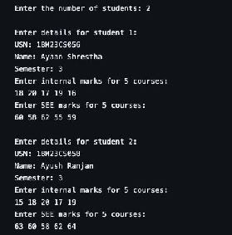Output :

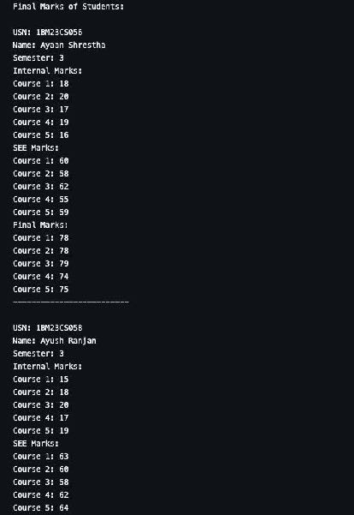

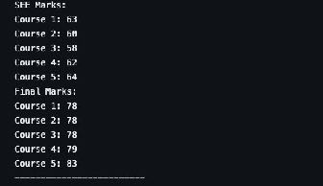

Program No : 7

Implement Exception Handling Algorithm :

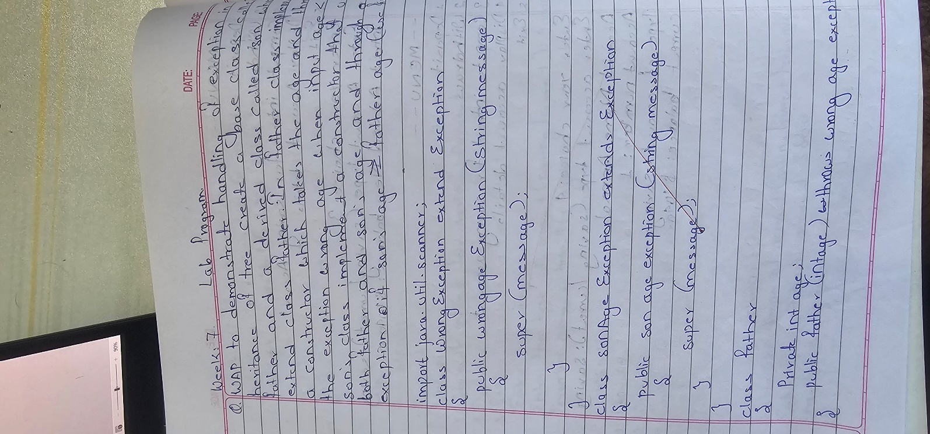

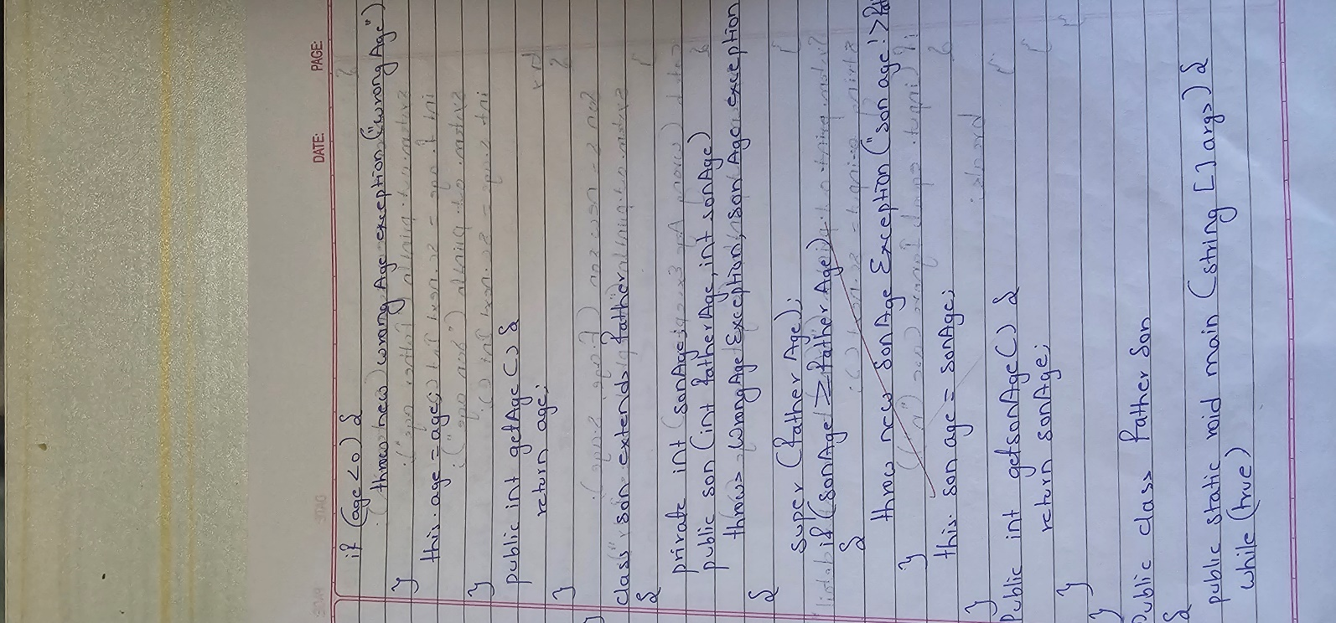

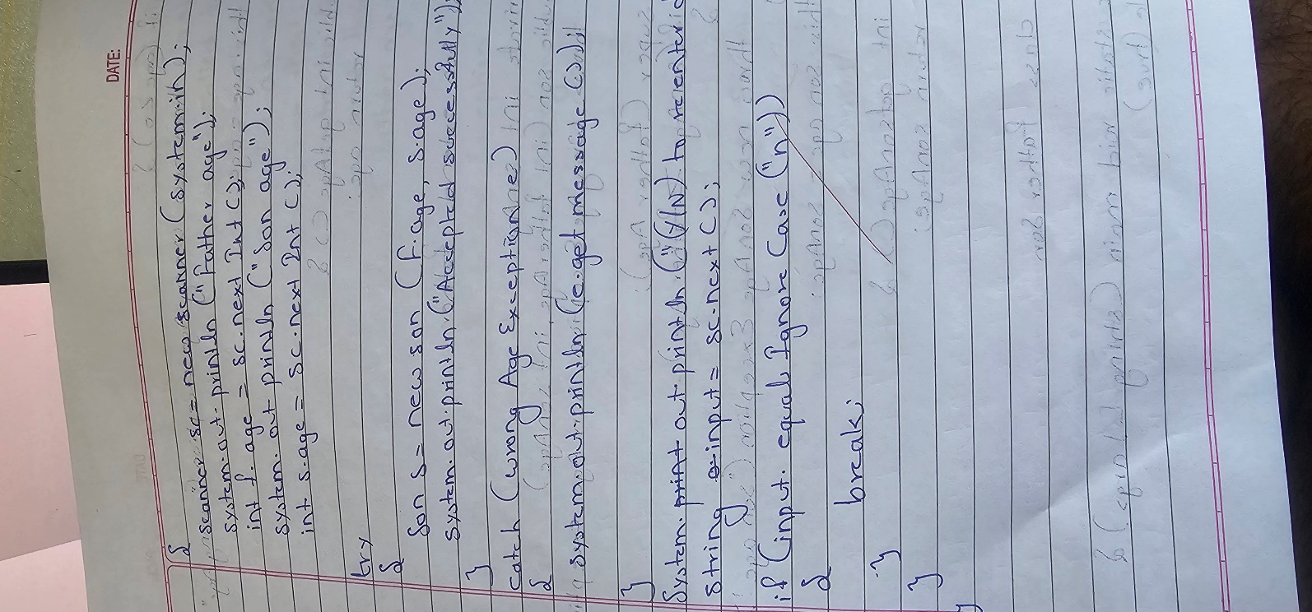

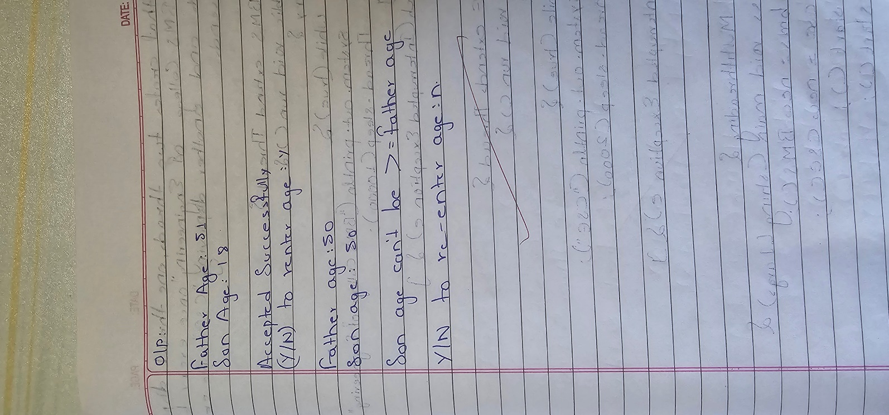

Code :

import java.util.Scanner;

class WrongAgeException extends Exception { public WrongAgeException(String message) {

super(message);

}

}

class SonAgeException extends Exception { public SonAgeException(String message) {

super(message);

}

}

class Father { private int age;

public Father(int age) throws WrongAgeException { if (age < 0) {

throw new WrongAgeException("Wrong age");

}

this.age = age;

}

public int getAge() { return age;

}

}

class Son extends Father { private int sonAge;

public Son(int fatherAge, int sonAge) throws WrongAgeException, SonAgeException {

super(fatherAge);

if (sonAge >= fatherAge) {

throw new SonAgeException("Son's age cannot be greater than or equal to father's age");

}

this.sonAge = sonAge;

}

public int getSonAge() { return sonAge;

}

}

public class FatherSon{

public static void main(String[] args) { while(true){

Scanner sc = new Scanner(System.in); System.out.print("Enter Father's Age: "); int fatherAge = sc.nextInt(); System.out.print("Enter Son's Age: "); int sonAge = sc.nextInt();

try {

Son son = new Son(fatherAge, sonAge); System.out.println("Accepted Succesfully");

}

catch (WrongAgeException e) { System.out.println(e.getMessage());

}

catch (SonAgeException e) { System.out.println(e.getMessage());

}

System.out.println("Would you like to re-enter details (Y/n)"); String input = sc.next();

if (input.equalsIgnoreCase("n")) { break;

}

}

}

}

Output:

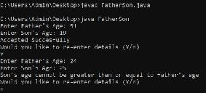

Program No : 8

Multithreading, Creating Threads in Java

Algorithm :

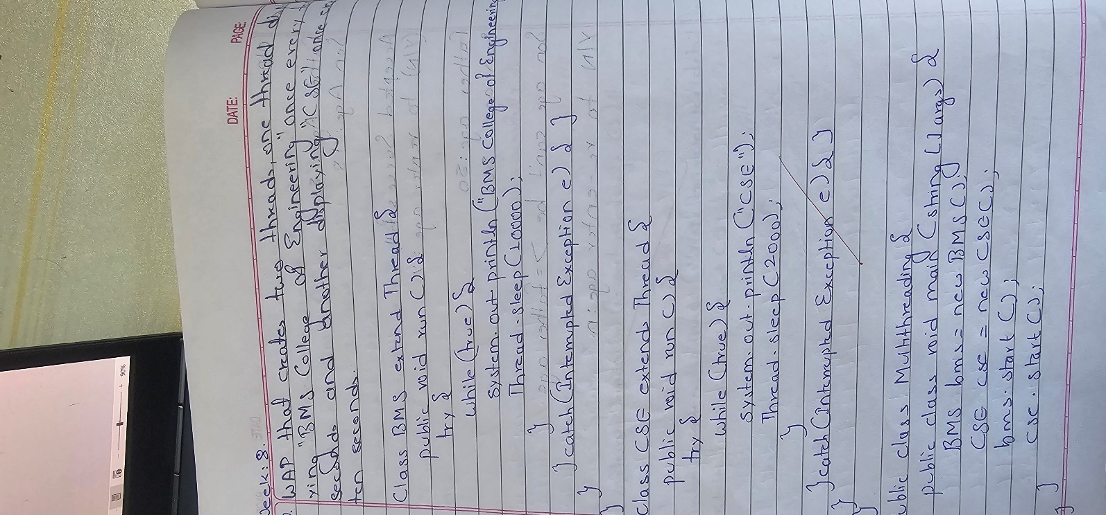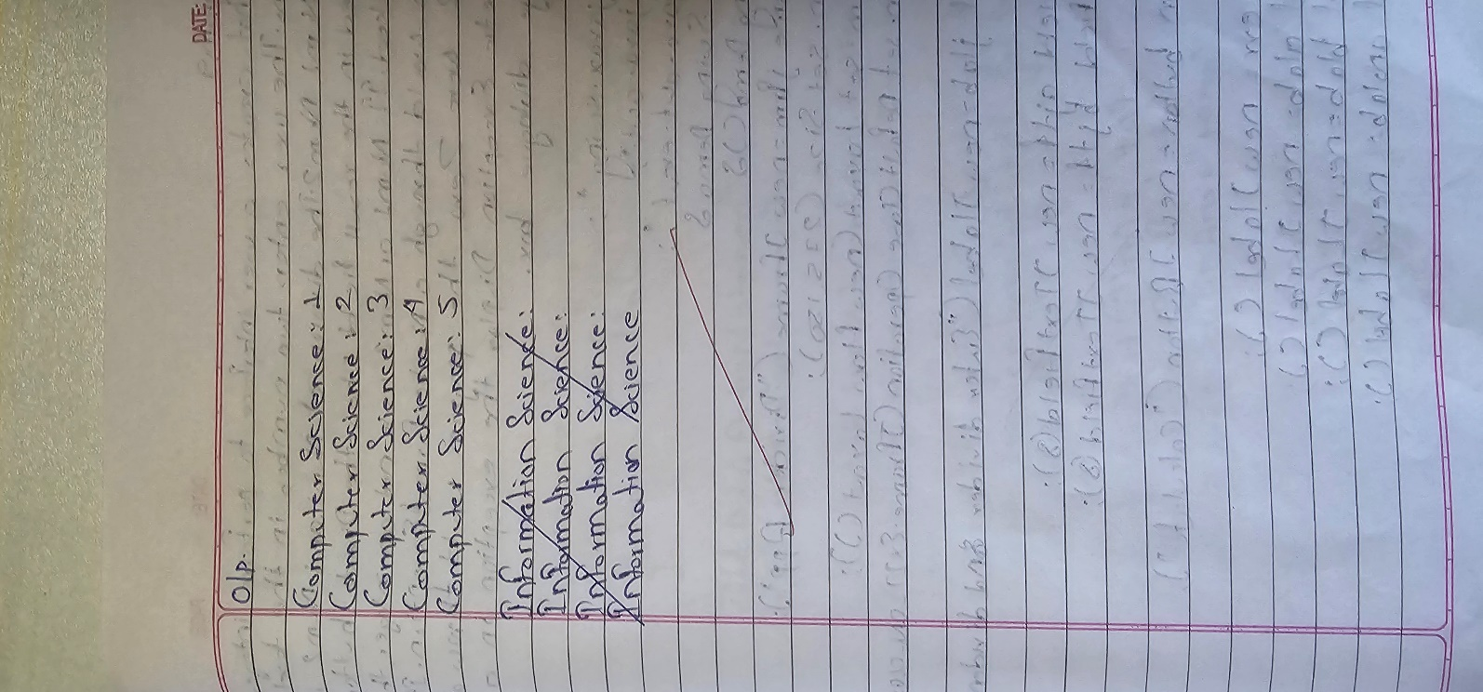

Code :

class BMS extends Thread { public void run() {

try {

while (true) {

System.out.println("BMS College of Engineering"); Thread.sleep(10000); // Sleep for 10 seconds

}

}catch (InterruptedException e) {}

}

}

class CSE extends Thread { public void run() {

try {

while (true) { System.out.println("CSE");

Thread.sleep(2000); // Sleep for 2 seconds

}

}catch (InterruptedException e) {}

}

}

public class Multithreading{

public static void main(String[] args) { BMS bms = new BMS();

CSE cse = new CSE(); bms.start();

cse.start();

}

}

Output:

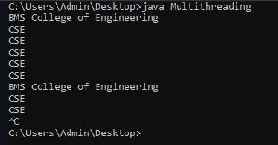

Program No : 9

Interface to Perform Integer Division

Algorithm :

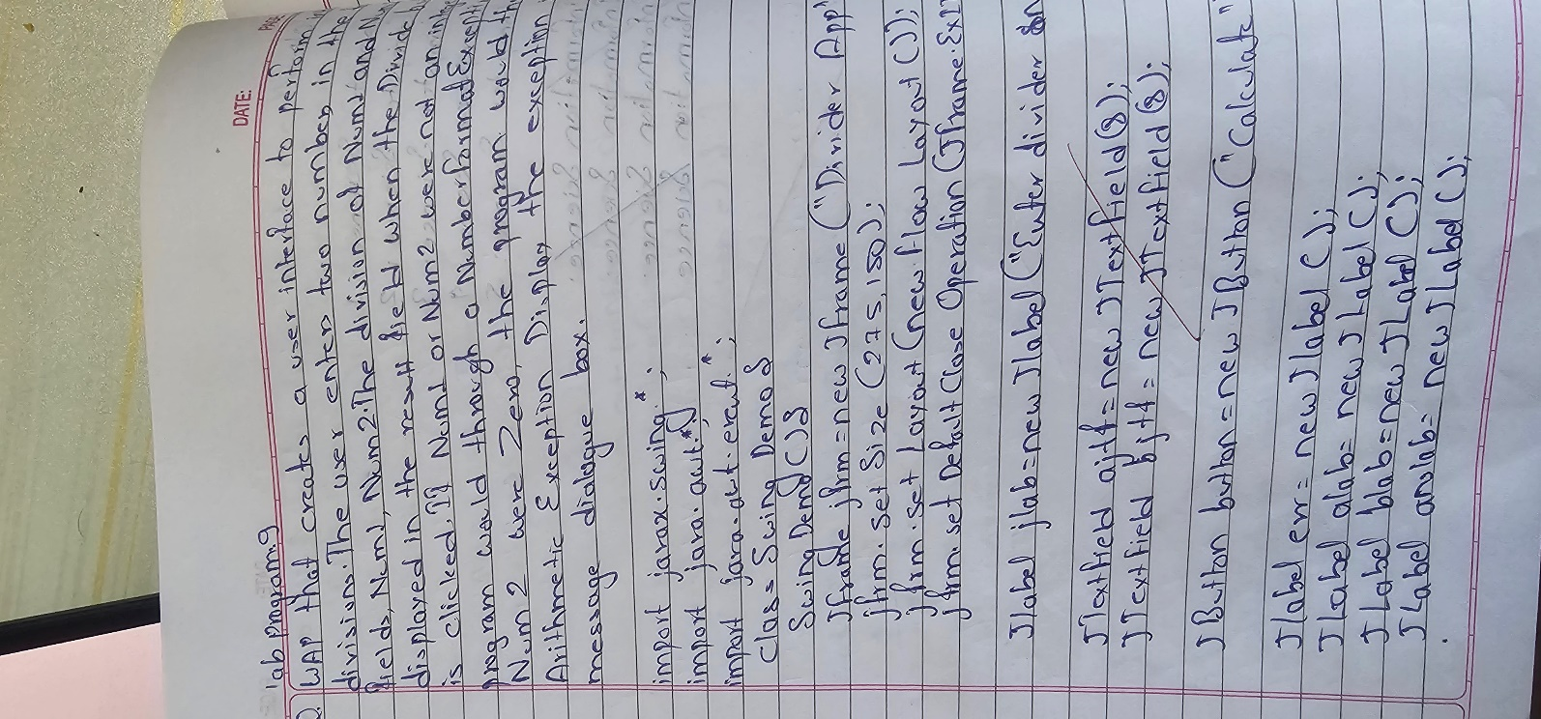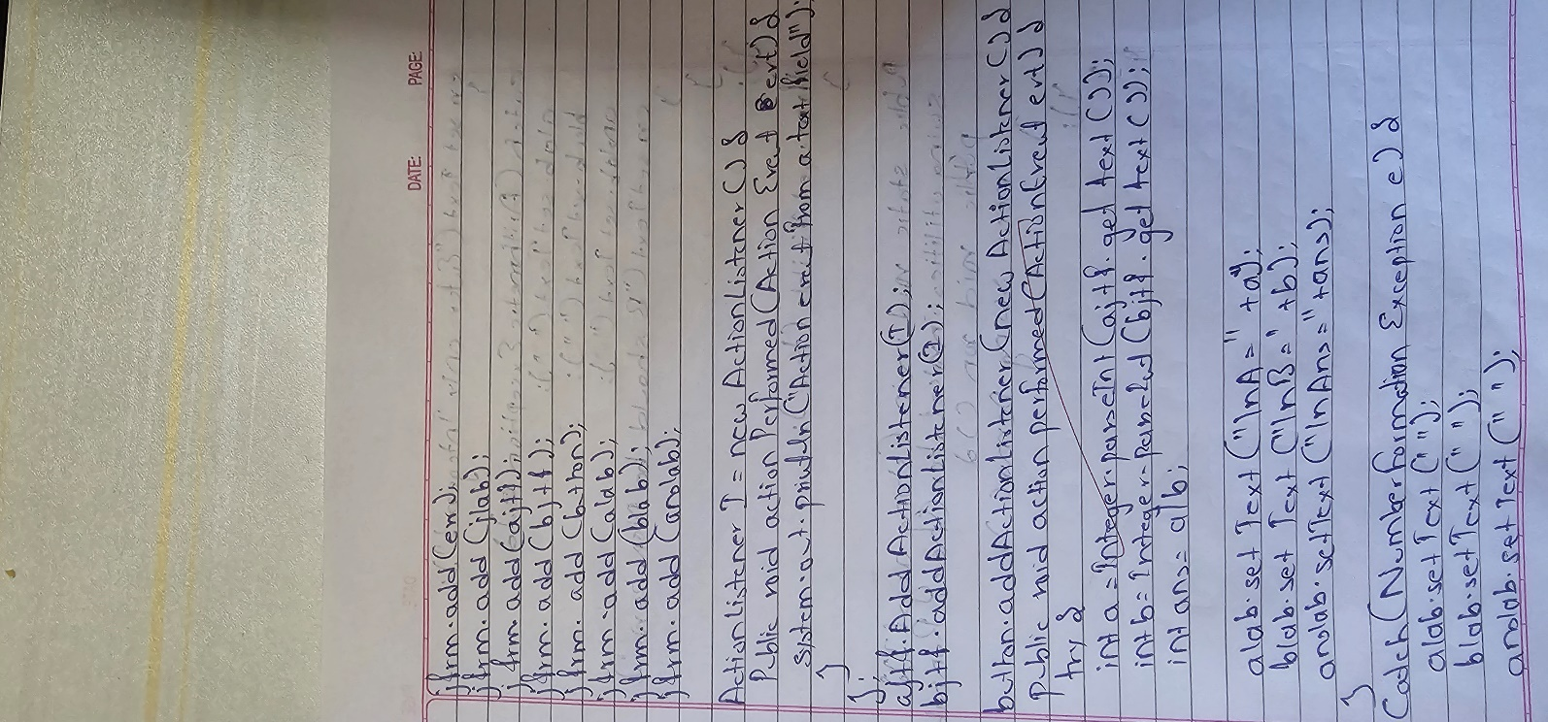

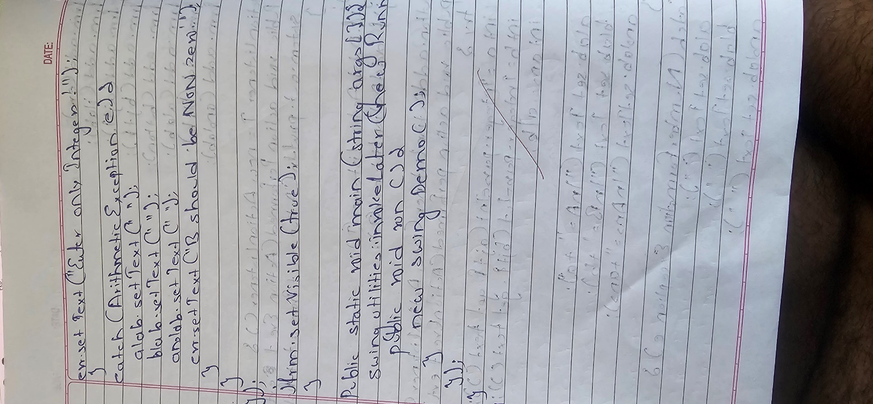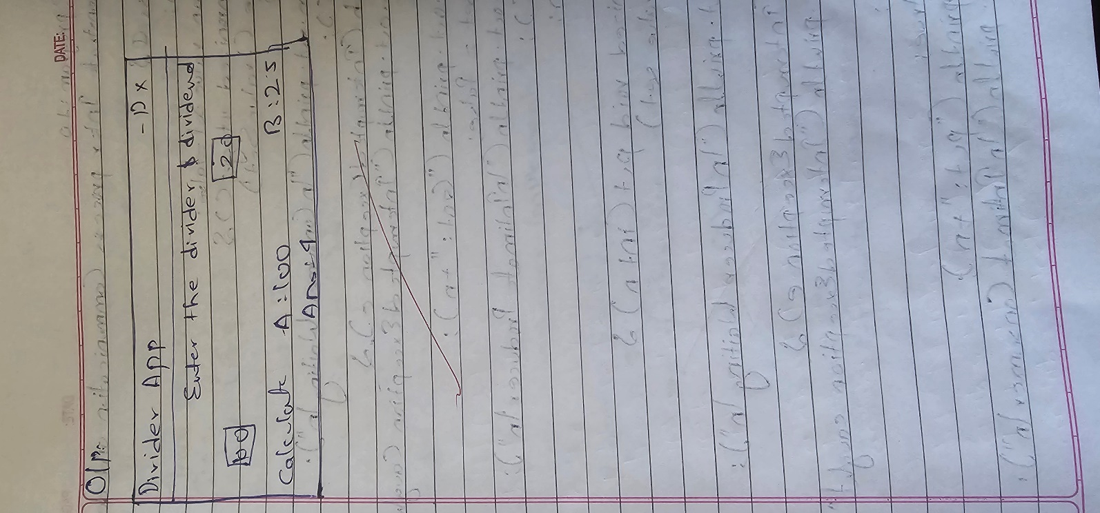

Code :

import javax.swing.*; import java.awt.*; import java.awt.event.*;

class SwingDemo { SwingDemo() {

JFrame jfrm = new JFrame("Divider App");

jfrm.setSize(275, 150); jfrm.setLayout(new FlowLayout());

jfrm.setDefaultCloseOperation(JFrame.EXIT_ON_CLOSE);

JLabel jlab = new JLabel("Enter the divisor and dividend:");

JTextField ajtf = new JTextField(8); JTextField bjtf = new JTextField(8);

JButton button = new JButton("Calculate");

JLabel err = new JLabel(); JLabel alab = new JLabel(); JLabel blab = new JLabel(); JLabel anslab = new JLabel();

jfrm.add(err); jfrm.add(jlab); jfrm.add(ajtf); jfrm.add(bjtf); jfrm.add(button); jfrm.add(alab); jfrm.add(blab); jfrm.add(anslab);

button.addActionListener(new ActionListener() { public void actionPerformed(ActionEvent evt) {

try {

int a = Integer.parseInt(ajtf.getText()); int b = Integer.parseInt(bjtf.getText());

int ans = a / b; alab.setText("A = " + a); blab.setText("B = " + b);

anslab.setText("Ans = " + ans);

err.setText("");

} catch (NumberFormatException e) { alab.setText("");

blab.setText("");

anslab.setText(""); err.setText("Enter Only Integers!");

} catch (ArithmeticException e) {

}

}

});

alab.setText("");

blab.setText("");

anslab.setText("");

err.setText("B should be NON-zero!");

jfrm.setVisible(true);

}

public static void main(String args[]) { SwingUtilities.invokeLater(new Runnable() {

public void run() { new SwingDemo();

}

});

}

}

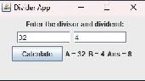Output :

Program 10.1 Implement Deadlock

Algorithm :

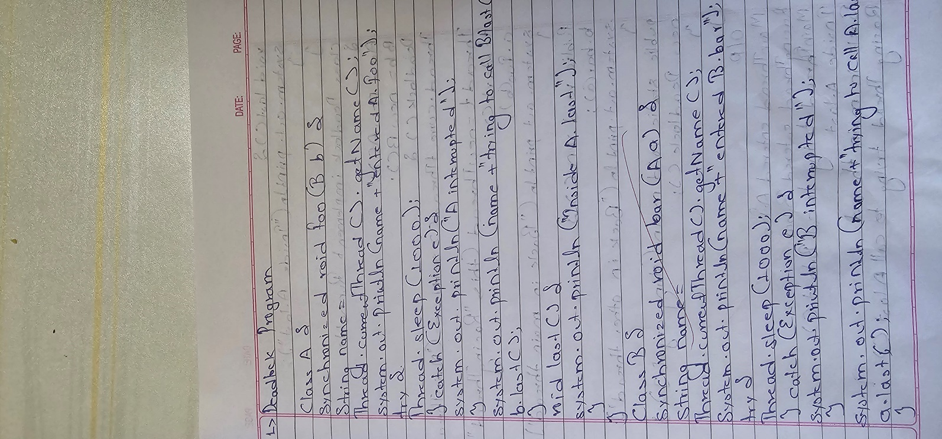

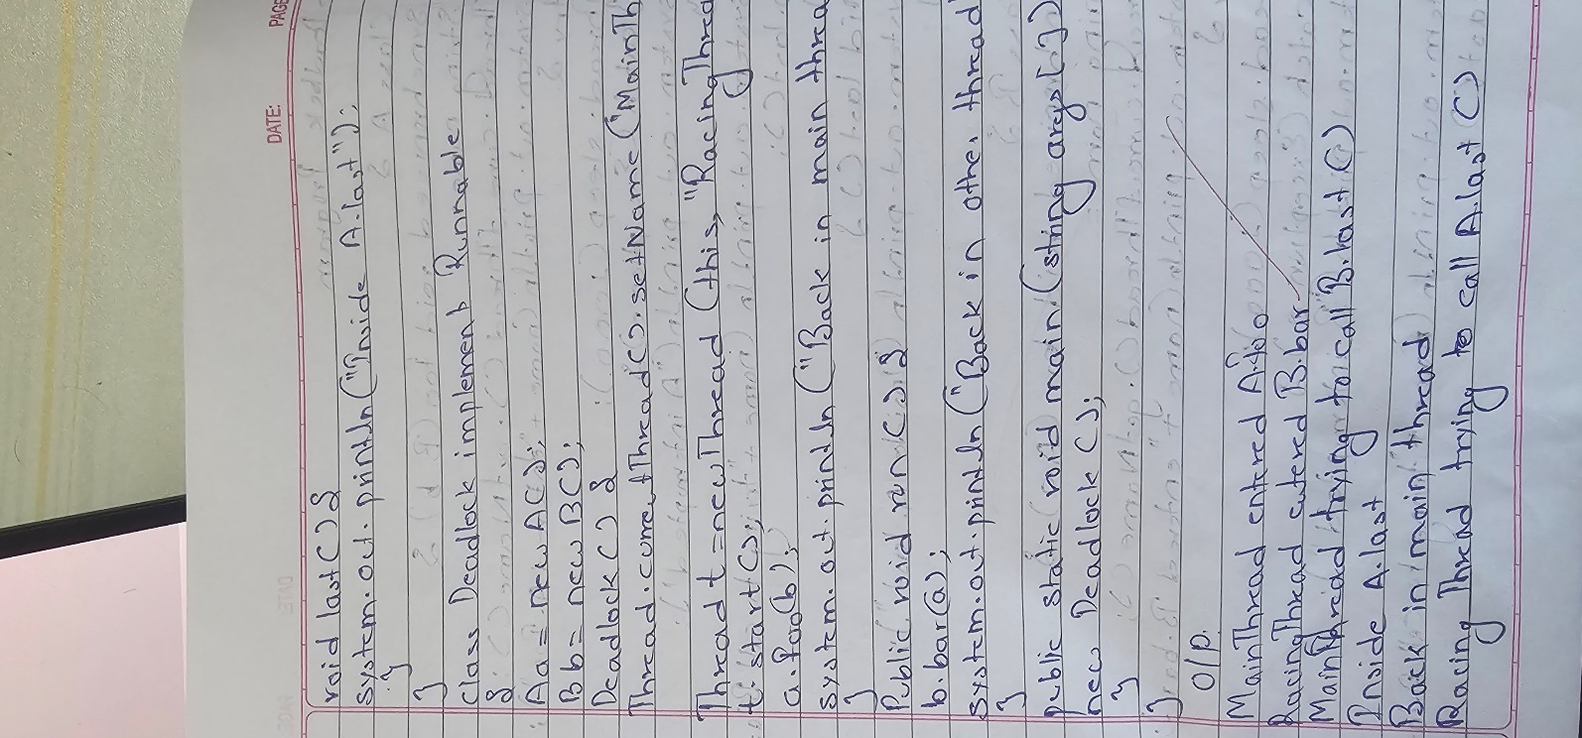

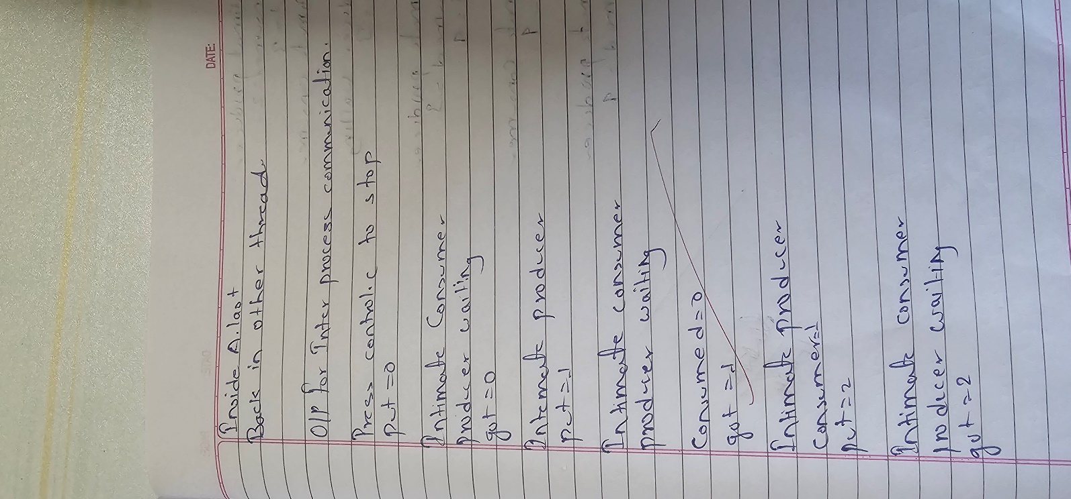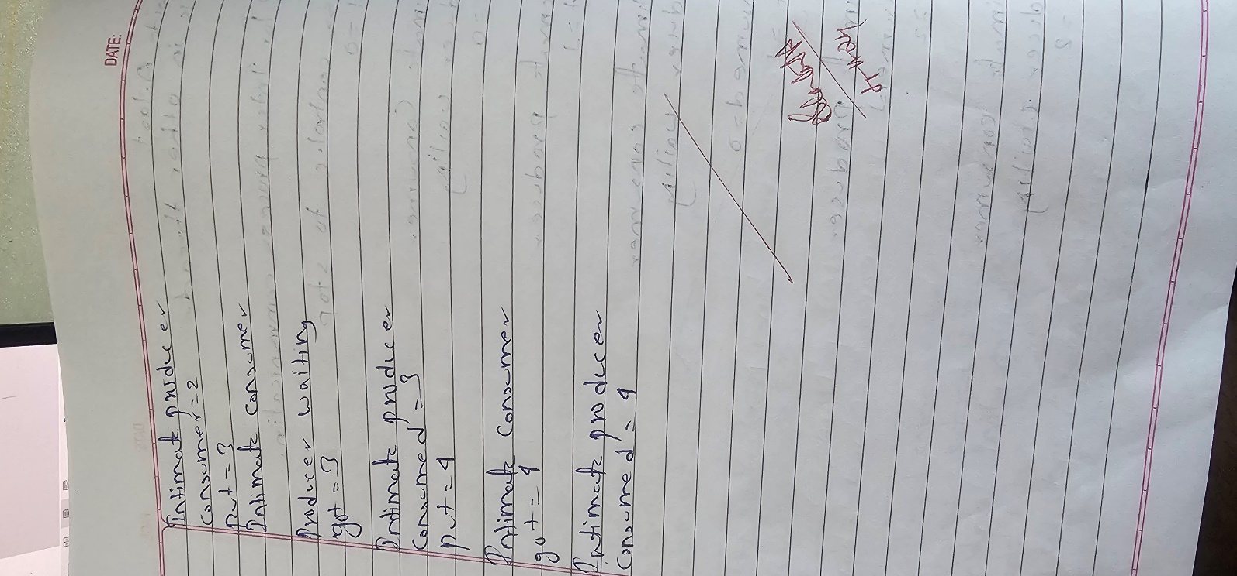

Code :

class A {

synchronized void foo(B b) {

String name = Thread.currentThread().getName(); System.out.println(name + " entered A.foo");

try {

Thread.sleep(1000);

} catch (Exception e) {

System.out.println("A Interrupted");

}

synchronized (b) {

System.out.println(name + " trying to call B.last()"); b.last();

}

}

void last() { System.out.println("Inside A.last");

}

}

class B {

synchronized void bar(A a) {

String name = Thread.currentThread().getName(); System.out.println(name + " entered B.bar");

try {

Thread.sleep(1000);

} catch (Exception e) { System.out.println("B Interrupted");

}

synchronized (a) {

System.out.println(name + " trying to call A.last()"); a.last();

}

}

void last() { System.out.println("Inside B.last");

}

}

class Deadlock implements Runnable {

A a = new A();

B b = new B();

Deadlock() { Thread.currentThread().setName("MainThread");

Thread t = new Thread(this, "RacingThread"); t.start();

a.foo(b);

System.out.println("Back in main thread");

}

public void run() { b.bar(a);

System.out.println("Back in other thread");

}

public static void main(String args[]) { new Deadlock();

}

}

Output:

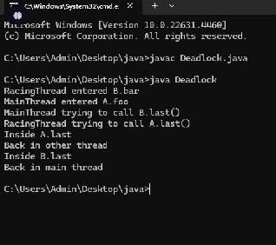

Program 10.2 :

Implement Inter-process Communication Algorithm :

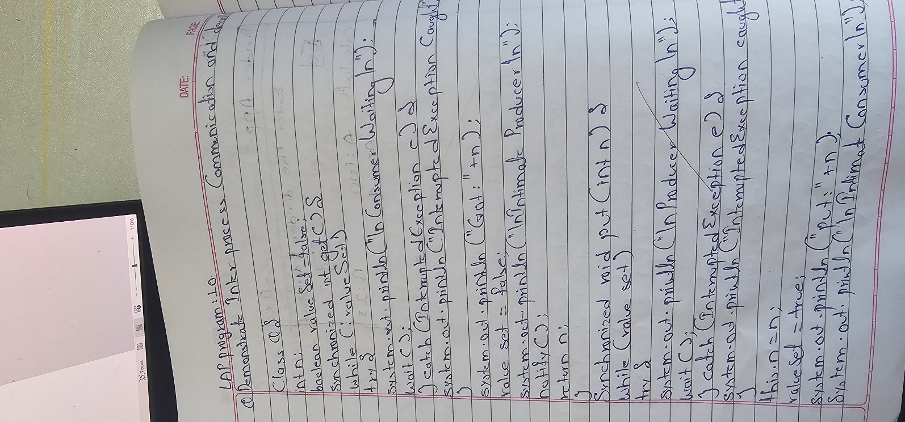

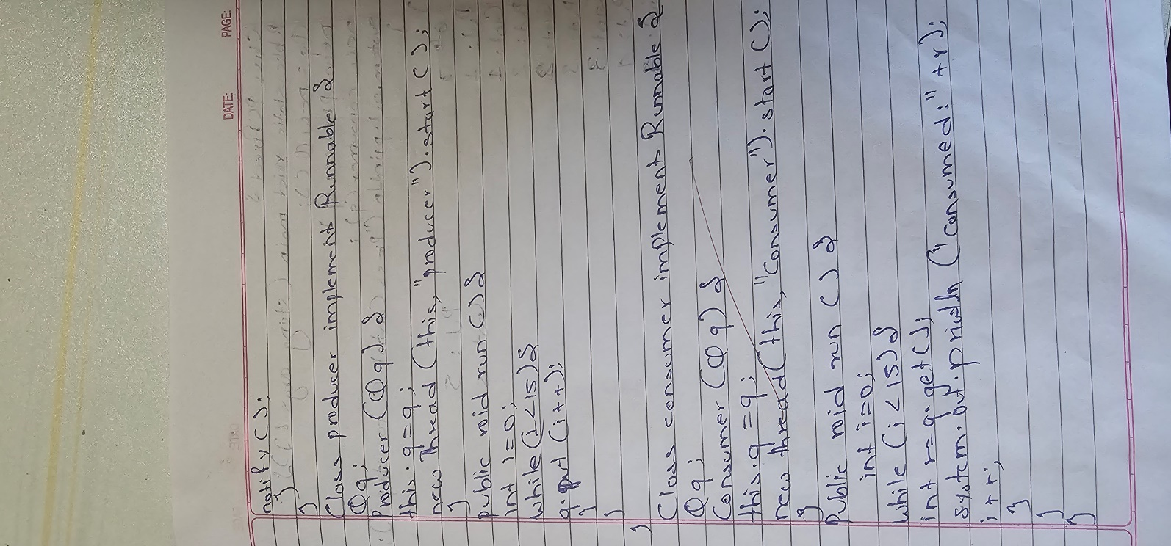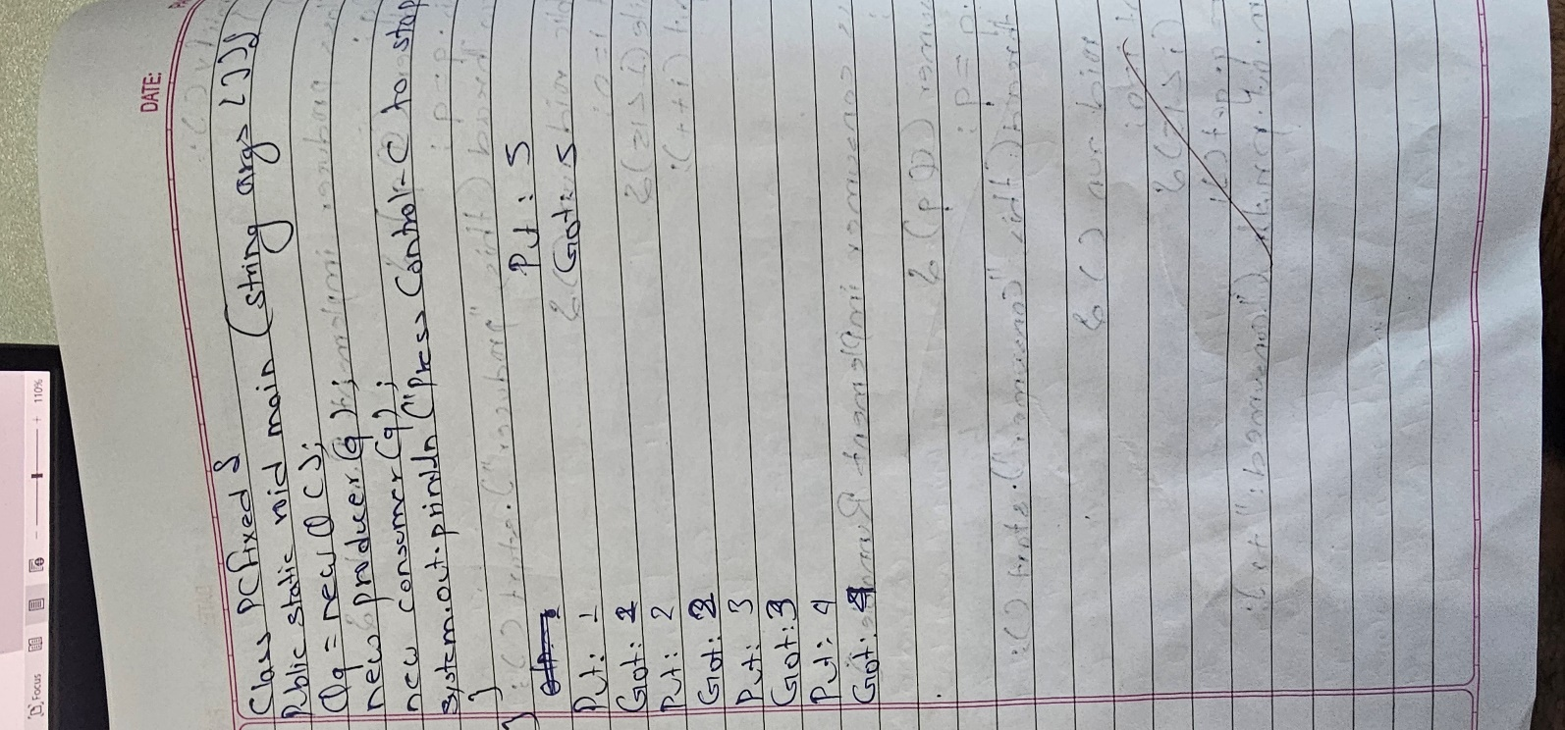

Code :

class SharedResource { private int data;

private boolean isDataAvailable = false;

public synchronized void produceData(int data) throws InterruptedException { while (isDataAvailable) {

wait();

}

this.data = data; System.out.println("Put: " + data); isDataAvailable = true;

notify();

}

public synchronized void consumeData() throws InterruptedException { while (!isDataAvailable) {

wait();

}

System.out.println("Get: " + data); isDataAvailable = false;

notify();

}

}

public class IPCDemo {

public static void main(String[] args) {

SharedResource sharedResource = new SharedResource();

Thread producer = new Thread(() -> { try {

for (int i = 0; i < 5; i++) { sharedResource.produceData(i); Thread.sleep(1000);

}

} catch (InterruptedException e) { e.printStackTrace();

}

});

Thread consumer = new Thread(() -> { try {

for (int i = 0; i < 5; i++) { sharedResource.consumeData(); Thread.sleep(1500);

}

} catch (InterruptedException e) { e.printStackTrace();

}

});

producer.start(); consumer.start();

System.out.println("Anmol Bhattarai 1BM23CS039");

}

}

OutPut:

